AOS3: Practical Investigation updated 11/2/17
Name: ___________________ Partner: ___________________
Submission Date: _______________________
Reference: This research investigation is based on the task “How does water quality differ at various points along a river ” (p30,31) and the information included in “Design scientific investigations” (p2,3) and Appendix 1: Scientific Investigations (p32-37) from VCAA Advice for teachers, Units 1&2, 2016-2020.
Task Outline
Outcome 3: A report of a student-designed quantitative laboratory investigation presented as a scientific poster.

Water quality is of great interest to the government and general public because it is directly connected to healthy communities. Many diseases can spread quickly through a contaminated water supply. In fact, it was because of the cholera outbreaks in London in the 1850s that John Snow was able to make the link between this deadly disease and contaminated water. In Australia, drinking water is treated and continually tested to ensure that it is safe for human consumption. However, it is also important to protect any water that may flow into lakes and dams, including small streams. Greenvale Reservoir is sited next to Aitken College and supplies water to the north-west and western suburbs. Although Brodies creek that runs through the school does not directly flow into the reservoir, its close proximity to a drinking water supply means that it needs to be protected.
Protecting the quality of water in our local waterways is also important for the plants and animals that live in the aquatic ecosystem. There are many factors that impact on the health of streams including farming and development of housing.
In this task you will undertake a practical investigation into how the quality of water in a local waterway is affected by external factors such as farming and urbanisation, and the types of water management strategies that can be used to minimise these effects. The investigation must include collection of quantitative data.
The findings of your investigation needs to be reported in a poster that follows the template shown below and does not exceed 1000 words.
- An investigation guide has been produced to guide you in the different phases of the investigation.
- All your experimental work needs to be documented in your log book.
- The assessment rubric also provides further information on the standard required in each skill.
Topic Selection and Planning Phase
- Identify a general question that can be used to focus the investigations.
- Write a research question that outlines the focus of your investigation.
- Establish the variables.
- Write a hypothesis.
- Identify the scope of the investigation.
- Set timeframes and milestones for the task.
Investigation Phase
- In this phase the following sections need to be completed and approved by your teacher.
- Research the background information related to your topic.
- Design the experiment.
- Undertake experimental work, ensuring that all data is recorded in your log book.
Reporting Phase
- Summarise data and represent in graphical forms as required.
- Analyse and evaluate your results using the assessment rubric as a guide.
Poster Requirements
Scientific posters follow particular conventions or formats as set out below:
Format
The poster must follow the format given below and must not exceed 1000 words. It can be in digital form.
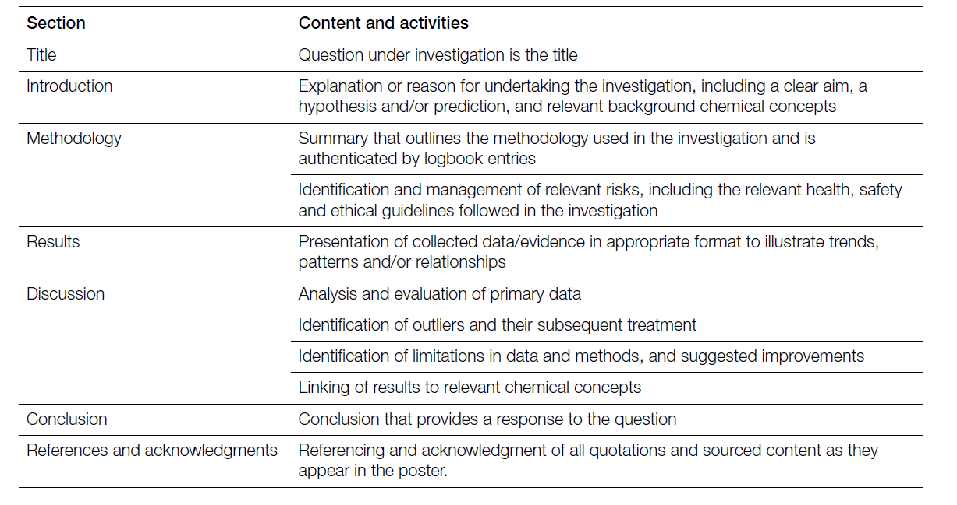
Writing Style
Posters are generally written in past tense, as they report on what has been done. However, if you are making recommendations you are able to use present tense. They are also written in an impersonal style with no pronouns such as ‘we’, ‘you’, or ‘I’ included.

Visual Communication
In posters much of the information is summarised using graphics. High standard posters will use graphics instead of words to convey information where possible. All graphics should be given a descriptive title.
The poster should be A2 size and the size of the font of the main text should be easy to read from a distance. The headings should be easy to identify in large font and the graphics should support the text.
Follow the link for some tips and ideas on creating effective Scientific Posters http://colinpurrington.com/tips/poster-design

Timeline
Lesson 1: Plan investigation – practical investigation question, variables, hypothesis and scope
Lesson 2: Write intro, aim, identify variables, materials list, method, risk assessment, results table
Lesson 3: Conduct experimental work
Lesson 4: Conduct experimental work. Construct results graph.
Lesson 5: Submit Rubric 1 sections of investigation in hard copy form – begin analysing results
Lesson 6: Complete discussion and conclusion under test conditions. Begin poster construction
Lesson 7: Complete poster - design headings/layout, insert graphics, design flow of text
Lesson 8: Poster sharing

Investigation Guide
Use this to guide your investigation. Include all information into your log book. The checklists and assessment rubric is a useful tool to ensure that your investigation is of the required standard.
Planning the Experiment
Practical Investigation Question
A practical investigation question is used to guide all parts of the investigation. It is important that your question is not too broad or too generalised. For example, “Does farming affect the water quality of a stream?” is too general as there are many types of farming and a large number of indicators must be measured to determine the quality of water. It would be better to narrow the investigation question down by being specific about what the factor is that affects water quality, and measuring one or two indicators of water quality. The question should also state what will be done in the investigation and should be able to be answered in a laboratory investigation and be applicable to a realistic scenario.
Research Question Checklist
states what will be done
can be answered experimentally
applicable to a realistic scenario

Variables and controls
In this section you need to identify the independent and dependent variables and also summarise what factors you will control. A variable can exist in differing amounts or types and can be measured. Use the table below as a guide.
Independent Variable  (what will you be changing) | Dependent variable  (what change will you be measuring) | Controls  (what will you keep constant in each trial)
Hypothesis
Hypothesis Checklist
Uses an ‘If___ then_____ because _______’ statement
States the independent variable.
States the dependent variable and the predicted effect
Provides theoretical justification

A hypothesis is an educated guess based on scientific ideas of what you think will happen. A good hypothesis will include a scientific reason to justify the reasoning and is usually written as an “If ________ then _______because_____” statement. It should also include the independent and dependent variables, as well as the predicted affect, supported by background theory.

Introduction
Introduction Checklist
Includes scientific theory
Relates theory to investigation question
Includes all sources at the end of poster

The introduction briefly outlines the relevant scientific theory. You need to give the reader a general overview of the scientific terms and concepts involved in your research project. Theory should be related to the investigation question.

Aim
Aim Checklist
States what will be done
States how it will measured
Uses a verb to begin sentence

This section states the purpose of the experiment. In this investigation the aim should explain what will be done, and how it will be measured. The sentence should also start with a verb, such as “to investigate, to measure, to verify, to determine, to compare or to calculate.”

Materials
Materials Checklist

All equipment and chemicals are listed
Includes the amounts of each item
In this section the equipment and chemicals that you used in the experiment need to be listed. It is important to also include how much of each item was used.

Method
Methods Checklist

Numerical steps are used
The steps are in correct order
Quantity of each item included
Is written in past tense
The method states how you conducted the experiment. The steps should be listed with numerical numbers and in the correct order. The method should also include how much of each item you used and be written in past tense.

Risk Assessment

When conducting an experiment, it is important to identify the risks and then state what precautions will be taken to prevent injury. This section must be completed before the experiment is conducted. Use the template that has been provided.

Conducting the Experiment

Observations
Observations include any changes that occur. Photos of different stages of the experiment can also form part of your observations. Remember to make notes of any unexpected results or how you could improve the experiment.
Observations Checklist
Includes observed changes
Includes information about unexpected results
Includes information about changes that could improve the experiment
Includes photos of experiment

Table of Results
The table(s) must have a title that describes the data, headings for each column and units. The independent variable should be in the far left column.
Table Checklist
Includes a descriptive title
Heading given for each column
Units are included
The independent variable is in the left column

Report Results
Graph of Results
The choice of graph needs to be suitable for the data that is collected. Generally, line graphs are used for continuous data, while bar graphs are used for data for separate categories. Graphs need to include a title that describes the data, labels on the axes with units and an appropriate scale. The dependent variable should be on the y axis.
Graph Checklist
Is a suitable graph for the data
Includes a detailed title
Axes are labelled, units included
Dependent variable is on the y axis
Appropriate scale is used

Analysing and Evaluating Data
Discussion
This section includes an analysis of your data, stating and explaining the key findings and evaluating the method. Use the assessment rubric to guide you.

Conclusion
Briefly summarises the key findings and states whether the aims of the investigation were achieved or not and. Discusses the implications of the research findings and proposal. No new information is included in the conclusion.

Bibliography
Use Harvard style: need to include the information shown in the table below.
– author (date) title of article, book title, web address, date accessed.
eg. Williams (2016) Multiple Myeloma, Encyclopaedia Britannica, http://school.eb.com.au/levels/high/article/54243, date accessed 11th February 2017.
All information from other sources must also be referenced with an in-text citation where the authors name and the year published or accessed is included.
eg. Multiple Myeloma is similar to Leukaemia in that there is an increase of abnormal cells in the bone marrow which results in a reduction in the immune system as the normal function of the bone marrow is compromised (Williams, 2016).

Risk Assessment Record
Activity  (title/reference) |  |  |  | Date of activity
Assessor  (name) |  |  |  | Class/level
Hazardous substance | Conc. | Amount | SDS date | Hazards – Risk phrases | Controls – Safety phrases
Risk control for all chemical experiments | - Safety goggles, gloves (or wash hands after use), laboratory coats and closed shoes  - Chemical labels, instructions for mixing and disposing chemicals must be followed  - Obey Science Safety Rules
Disposal

Other risk controls for this activity

Assessor (signed) |  |  |  | Date of record

Assessment Rubric 1: Planning, Conducting and Reporting on the results

 | asks questions that compare two or more variables | makes predictions that follow set conventions |  |  |  |  | evaluates quality of data
↑ | asks questions that can be tested | makes predictions based on theory | distinguishes between factors to control, measure and change | records observations relevant to method | uses a table that follows the set conventions | uses a graph that follows the set conventions | identifies trends and/or patterns
 | asks questions | predicts outcomes | identifies factors to change | records observations | records data | includes graph | summarises data
Skill | identifies purpose | makes predictions | identifies factors | makes observations | records data | represents data | reports data
 | Planning the experiment |  |  | Conducting the Experiment |  | Reporting Results

Assessment Rubric 2: Analysing and Evaluating, Communicating Results

 |  | makes generalisations based on key findings
 |  | uses theory to link or reconcile key findings including outliers | assesses effect of errors on quality of data |  | makes recommendations to overcome limitations
 | justifies evaluation of predictions | explains key findings using theories | distinguishes between types of errors | predicts effect of modifications on quality of data | identifies limitations of key findings |  | applies ideas to new contexts | creates scientific poster appropriate for intended audience
↑ | makes connections between predictions and data | matches key findings with theory | explains errors | explains how modifications improve design | summarises key findings in relation to aim | uses required scientific conventions | explains key chemical ideas | present information using a scientific format | uses required style (Harvard)
 | evaluates predictions | identifies key findings | identifies errors | suggests modifications for the method | includes conclusive key findings | includes information | uses chemical terminology | represents information on poster | lists sources
Skill | evaluates predictions | analyses results | evaluates method | modifies method | makes conclusions | uses set conventions | forms ideas  (Intro/Disc/Conc) | designs poster | referencing sources
 | Analysing and Evaluating |  |  |  |  | Communicating Results (Scientific Poster)

