Skill session: Does the melting point of a fuel depend on the size of the molecules?
This task addresses the following Key knowledge descriptors:
- U3 AOS1 KK - the comparison of fossil fuels (coal, petroleum gas, coal seam gas) and biofuels (biogas, bioethanol, biodiesel) with reference to energy content, renewability and environmental impacts related to sourcing and combustion
- U4 AOS3 KK –identify dependent, independent and controlled variables and write hypotheses
- Key Science skill - draw conclusions consistent with evidence and relevant to the question under investigation, identify, describe and explain the limitations of conclusions, including identification of further evidence required
Review – variables and writing a hypothesis
What is a variable?
A variable is any factor, trait, or condition that can exist in differing amounts or types.
What types of variables are used in an experiment?
- independent variables
- dependent variables
- controlled variables
Independent variable
The independent variable is the condition you change during the experiment. Only one independent variable is changed at a time.
Dependent variable
The dependent variable(s) are those that are monitored to see how they respond to the change made to the independent variable. It is often what is measured.
Controlled variable(s)
Controlled variables are those factors that need to remain constant. It is important to keep these factors these same so that the experiment is conducted under the same conditions each time.
Example:
Research Question | Independent Variable | Dependent Variable(s) | Controlled Variable(s)
Is the amount of energy released during combustion of a fuel dependent on the hydrogen/carbon ratio of the fuel? | Fuels with different hydrogen/carbon ratio | Energy released during combustion. This will be determined by measuring the temperature change in a bomb calorimeter. | - Variables related to the bomb calorimeter; stirrer, ignition source,  - Fuel volume

What is a hypothesis?
The hypothesis is a statement about what is expected to occur in the investigation that is based on limited information or evidence. The hypothesis will often include the independent and dependent variables and is related to the research question so it is important to have identified these first.
How to write a hypothesis
There are several ways that a hypothesis can be written. Some suggestions are given in the VCE Advice for teachers – Chemistry, http://www.vcaa.vic.edu.au/Pages/vce/studies/chemistry/chemindex.aspx. An informative slide presentation can also be found at: https://www.slideshare.net/jan_parker/ind-and-dep-variables-plus-hypothesis
One way to construct a hypothesis is to follow the pattern:
If the dependent variable (depends on, results from, is affected by, is directly related to) the independent variable then the dependent variable will (show an increase/ decrease, be greater than/less than, be larger/smaller) when the independent variable is (increased/decreased, greater/less, large/small).
A hypothesis for the above research question could be:
If the energy released during combustion is dependent on the hydrogen/carbon ratio of a fuel then the energy output will be greater when a fuel with a high hydrogen/carbon ratio is combusted than when a fuel with a low hydrogen/carbon ratio is combusted.

Skill session: Does the melting point of a fuel depend on the size of the molecules?
Outline
For the fuels, coal, kerosene, paraffin wax, coconut oil, bioethanol and methane investigate whether the melting (or sublimation) point of a fuel is dependent on the size of the molecule
Aim
To determine whether the melting point of a fuel depends on the size of the molecule.
Variables
Identify the independent and dependent variables and the controlled variables.
Research Question | Independent Variable | Dependent Variable(s) | Controlled Variable(s)
Does the melting (or sublimation) point depend on the type of bonding between molecules or atoms.

Method
Sort the chemical structures into similar size molecules and compare this order with the known melting (or sublimation) points.

Coal: 5530ºC, paraffin wax: 68ºC, coconut oil: 24ºC, kerosene: -47ºC, ethanol: -144.1ºC, methane: -182ºC

Discussion
- Was there any correlation between the size of the molecules and the order of the melting or sublimation points? If yes, suggest an explanation for this observation.

- Were there any discrepancies between the size of the molecules and melting or sublimation point? If yes, provide a possible explanation for your findings.

- Write a conclusion for this investigation. In your conclusion, identify any limitations and whether further evidence is required.

Chemical structures of fuels
coal  > 200 carbons  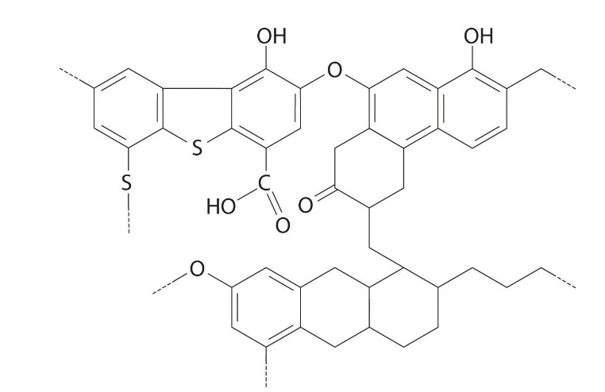 | coconut oil  approx. 40 carbons  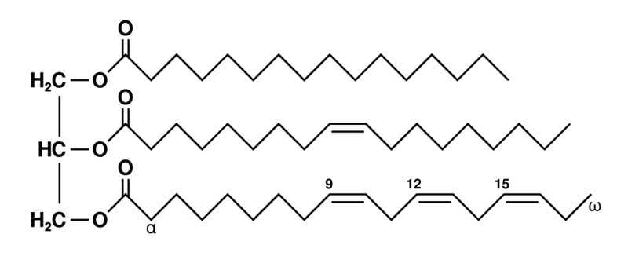
bioethanol  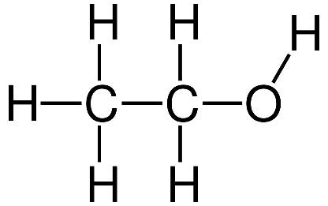 | kerosene  mixture of straight chained and branched hydrocarbons of 6-10 carbons  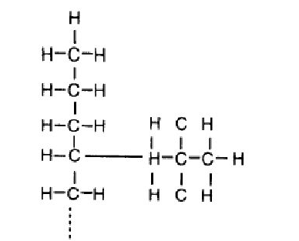
paraffin wax  Mixture of hydrocarbons ranging from 20 – 40 carbons  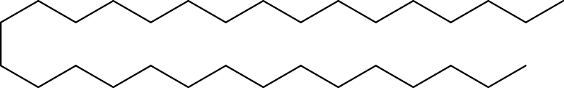 | methane  