Chemistry Unit 4 AOS2 Response to stimulus material Name: _________________
Question 1 (7 marks) TOTAL: 28 marks
Sarcopenia is the progressive loss of muscle mass with aging. Although muscle loss declines slowly from the age of 30, it can eventually lead to a reduction of movement and strength with a greater risk of injury from falls.
Health professionals have found that older people who do regular resistance training and include protein in their diet can build muscle strength and power.
- Dairy products such as yogurt contain the protein, casein. Many amino acids are present in this protein including glycine, cysteine, glutamic acid, aspartic acid and alanine. Demonstrate your understanding of the primary, secondary and tertiary bonding present in the protein structure and describe how this structure can be denatured.
In your answer:
- show the structure of a section of the protein, labelling the various types of bonding
- identify the types of bonding affected in denaturation of the protein. (4 marks)

Primary structure, secondary structure, tertiary structure – 3 marks Show structure with actual examples of bonding; Apply, written answer, U4 AS1 - 1
Denaturation -1 mark; Understand, written answer U4 AS2-6, U4 AS2-7

Students draw a section of protein showing peptide bond for primary, an example of secondary bonding, at least two examples of tertiary bonding. (2 marks)
Student describe how the structure can be denatured in high or low pH or high temperatures (1 mark)
Show or state that this denaturation causes disruption of the secondary and tertiary bonds but not the primary bonds. (1 mark)

- Milk contains the water-soluble vitamin Riboflavin which is thought to have important antioxidant properties. Compare the structure of riboflavin (Figure 1) with that of vitamin D₂ and explain the differing solubility’s of the two vitamins. (3 marks)
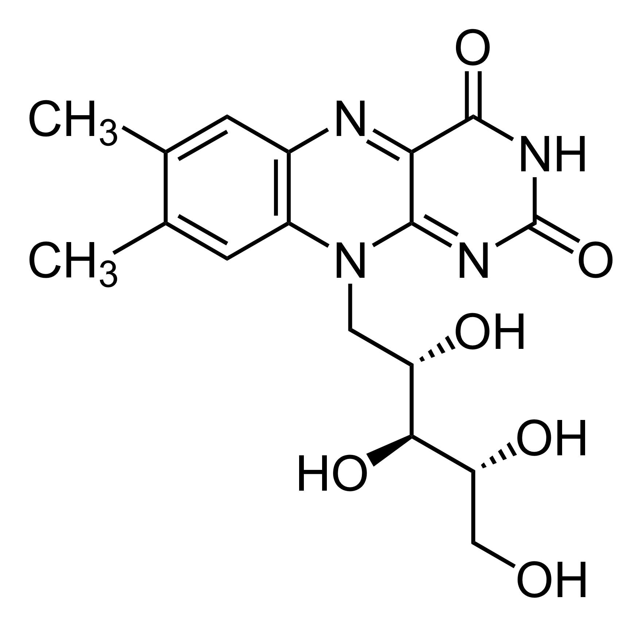
Figure 1. Chemical structure of riboflavin.
Vitamin D₂ is fat soluble (1 mark); Understand, written answer, U4 AS2-4

Although Vitamin D₂ has one site where hydrogen bonding can occur the entire structure is largely non polar with a long carbon hydrocarbon chain and three carbon hydrocarbon structures. (1 mark)
Understand, written answer, U4 AS2-4
Riboflavin contains a non polar component with the benzene ring, but it is has a larger polar component with a large number of hydrogen bonding sites due to presence of hydroxyl groups and amino and carbonyl groups. (1 mark)
apply, written answer, U4 AS2-4

Question 2 (7 marks)
Ironman events include a 3.86 km swim, a 180.25 km bicycle ride and a 42.20 km run. It took the athlete Julian 12 hours and 35 minutes to complete the entire event. Throughout the event he used 1000 kilojoules of energy per hour.
- An energy bar contains 70 g of carbohydrates, of which 25 g is present as glucose. Describe why it is essential that athletes consume foods with high amounts of carbohydrates.
In your answer:
- give the thermochemical equation for cellular respiration, in kJ.mol⁻¹, if the respiration of glucose releases 15.88 kJ.g⁻¹
- provide the number of energy bars that is required by Julian. (4 marks)

Glucose is the primary energy source in the body, being used in cellular respiration to produce ATP (energy).
Remember, written answer, U4 AS2-12
(1 mark)

C₆H₁₂O₆ + O₂ CO₂ + H₂O ∆H = - 2860 kJ.mol⁻¹ Remember, chemical equation, U4 AS2-12 (1 mark)

Time taken for the average athlete to complete race; 12.58 hours. Apply, calculation, U4AS2-11
Energy requirements; 12583.33 kJ
Now carbohydrates release 16 kJ.g⁻¹. Therefore, if the 12583.33/16 = 786.46 g of carbohydrates required.
Simple method; 786.46/70 = 11.23 energy bars.
More challenging method; One bar gives 25g glucose and 45g of other carbs; (25 x 15.88+45 x 16) = 1117 kJ.
Athlete will need to consume 11.265 energy bars. (2 marks)

- Glucose is a suitable source of carbohydrates during a race as it provides a quick release of energy. However, for daily consumption, nutritionists recommend more complex carbohydrate sources such wholemeal bread. Explain. (3 marks)
Need three out of the four responses provided below:
Whole meal breads are preferred because they have a low glycaemic index (GI) value. Understand, written answer U4AS2-8 (1 mark)
The glycaemic index is the relative ability of food to increase the level of glucose in the blood. (1 mark)
Understand, written answer U4AS2-8
Whole meal bread contains high amounts of husks which composed predominantly of cellulose. The low GI value is due to:
- the low surface area of the whole meal husks which slows enzymatic hydrolysis of starch portion of the product (1 mark)
- the lack the cellulase enzyme in the human body prevents hydrolysis of cellulose. (1 mark)

Apply, written answer U4AS2-8
Other answers that were given marks from students;
Low GI foods often contain higher amounts of amylose, a straight chain starch which is able to pack tightly together. This limits enzymes from being able to hydrolyse the glycosidic links and slows the rate of reaction.
Foods with higher amounts of amylopectin have a higher GI as the branching prevents close packing and more easy access to glycosidic links.

Question 3 (7 marks)
Linolenic acid is an omega 3 fatty acid, which is found in many foods including flax seeds.
- Linolenic is an essential fatty acid while arachidonic is a non-essential omega 6 fatty acid. Compare the structures and the physical properties of linolenic and arachidonic fatty acids.
In your answer:
- describe the structural differences between linolenic acid and arachidonic acid
- explain why one is known as an essential fatty acid and the other non-essential.
- predict whether linolenic or arachidonic fatty acid will have the lowest melting point. Justify your answer. (4 marks)
Linolenic acid is an omega 3 fatty acid which means it has a double bond on the third carbon from the end of the chain, while arachidonic is an omega 6 fatty acid where the double bond is on the six carbon from the end of the chain. Understand, written answer, U4AS2-3 (1 mark)
An essential fatty acid must be consumed in the diet, while non-essential fatty acid can be produced in the human body. Understand, written answer, U4AS2-3 (1 mark)
Arachidonic fatty acid will have a lower melting point (-49ºC) because it has four cis carbon-carbon double bonds while linolenic only has three cis double bond (-5ºC). (1 mark)
The presence of cis carbon-carbon double bonds creates a kink in the chain which prevents the molecules from packing closely thereby has weaker dispersion force attractions between the chains. The additional cis carbon-carbon double bond in linolenic further weakens the dispersion force attractions. (1 mark) apply, written answer, U4AS2-3
- Vegetable oils such as flaxseed oil contain high amounts of polyunsaturated fatty acids. One of the disadvantages of these types of oils is that they can easily become rancid. Demonstrate your understanding of the chemistry of this process.
In your answer:
- give an example of a chemical reaction that leads to oxidative rancidity
- identify the molecules that are predominantly responsible for the bad smelling odours in rancid oils.
- Identify a method that can be used slow the rate of rancidity and describe how it works. (3 marks)

autoxidation – where free radicals breaks a bond in fatty acid to form a free radical. A chain reaction begins when radical reactions with oxygen to form ROO. Which then reacts with another fatty acid. This molecule is unstable and can break into small molecular weight aldehydes and ketones (1 mark). understand, chemical equation, U4AS2-9
This reaction terminates when two radicals combine. understand, written answer, U4AS2-9 (1 mark)
Need at least one of these answers for 1 mark
The rate of rancidity can be slowed by refrigeration -reduce number of collisions and lowers proportion of particles with energy greater than activation energy.
antioxidants prevent the propagation of free radicals. understand, written answer, U4AS2-9
Question 4 (7 marks)
A research scientist compared two methods of calibration of a solution calorimeter. In the first method, they used electrical calibration while in the second method they used chemical calibration where the temperature change produced by the known reaction is used to determine the heat capacity of the calorimeter.
They obtained a calibration factor of 435 J.ºC⁻¹ using the electrical calibration method while they obtained a calibration factor of 315 J.ºC⁻¹ from using the heat of neutralisation of hydrochloric acid with sodium hydroxide.
The research scientist poured in 100 mL of water and added 3.2 g of potassium nitrate with stirring. The scientist measured a decrease in temperature of 2.7ºC.
- A standard table states that the heat of solution for potassium nitrate is +34.89 kJ.mol⁻¹. Use your understanding of calorimetry to identify which calibration method will produce the most accurate result.
In your answer:
- provide evidence to justify your response
- outline an error that lead to the overestimation or underestimation of the heat of solution of potassium nitrate. (4 marks)
Electrical calibration gave the most accurate result. evaluate, written answer, U4AS2-13 (1 mark)
n(KNO₃) = 3.2/(39.1 + 14.0 + 3x16.0) = 0.0317 mol

Electrical Calibration factor; 435 J.ºC⁻¹
CF = E/∆T, therefore, E =CF x ∆T, E = 435 x 2.7 = 1174.50 J for 0.0317 mol of KNO₃
Therefore, E = +37.05 kJ.mol⁻¹ (1 mark)

Chemical calibration factor: 315 J.ºC⁻¹
CF = E/∆T, therefore, E =CF x ∆T, E = 315 x 2.7 = 850.50 J for 0.0317 mol of KNO₃
Therefore, E = +26.96 kJ.mol⁻¹ (1 mark)
apply, calculation, U4AS2-13
One of the following errors;
- As electrical calibration is calculated using E = VIt, higher readings of the voltage or the current will result in an overestimation of the CF and therefore of the heat of solution.
- Slow stirring could result in higher temperature readings by probe due to inconsistent mixing – therefore, higher temperature difference will result in lower CF and an underestimation of heat of solution.
- If inconsistent stirring causes stratification in the solution calorimeter, then higher temperatures near the temperature probe will lead to an overestimation of the heat of solution. (1 mark)
evaluate, written answer, U4AS2-13
- In further experiments the scientist proved that the combustion of the amino acid, glutamine, released the same amount of energy in both acidic or basic conditions. Explain this key finding.
In your answer, show the structure of glutamine in both acidic and basic conditions. (3 marks)

Show the structure in acidic and basic conditions. Should show both amino groups protonated in acidic conditions, the carboxyl with loss of hydrogen ion in basic conditions. (2 marks)
Apply, chemical structures, U4AS2-6

The energy content is the same because amino acid has the same number carbon- carbon, carbon- hydrogen bonds, carbon- oxygen double bonds and carbon-oxygen single bonds.
The acidic conditions contributes two more nitrogen-hydrogen bond but these are proton assisted bonds which are weaker than normal covalent bonds (1 mark)
Apply, written answer, U4AS2-6
Bond energies
Nitrogen – hydrogen; 386 kJ/mol Carbon – carbon; 346 kJ/mol
Carbon – oxygen double bond; 799 kJ/mol Carbon – oxygen single bond; 358 kJ/mol
Carbon-hydrogen; 411 kJ/mol Oxygen-hydrogen; 459 kJ/mol

