Chemistry Unit 4 AOS2 Response to stimulus material Name: _________________
Question 1 (7 marks) TOTAL: 28 marks
Sarcopenia is the progressive loss of muscle mass with aging. Although muscle loss declines slowly from the age of 30, it can eventually lead to a reduction of movement and strength with a greater risk of injury from falls.
Health professionals have found that older people who do regular resistance training and include protein in their diet can build muscle strength and power.
- Dairy products such as yogurt contain the protein, casein. Many amino acids are present in this protein including glycine, cysteine, glutamic acid, aspartic acid and alanine. Demonstrate your understanding of the primary, secondary and tertiary bonding present in the protein structure and describe how this structure can be denatured.
In your answer:
- show the structure of a section of the protein, labelling the various bonding
- identify the types of reactions involved in denaturation of the protein. (4 marks)

- Milk contains the water-soluble vitamin Riboflavin which is thought to have important antioxidant properties. Compare the structure of riboflavin (Figure 1) with that of vitamin D₂ and explain the differing solubility’s of the two vitamins. (3 marks)

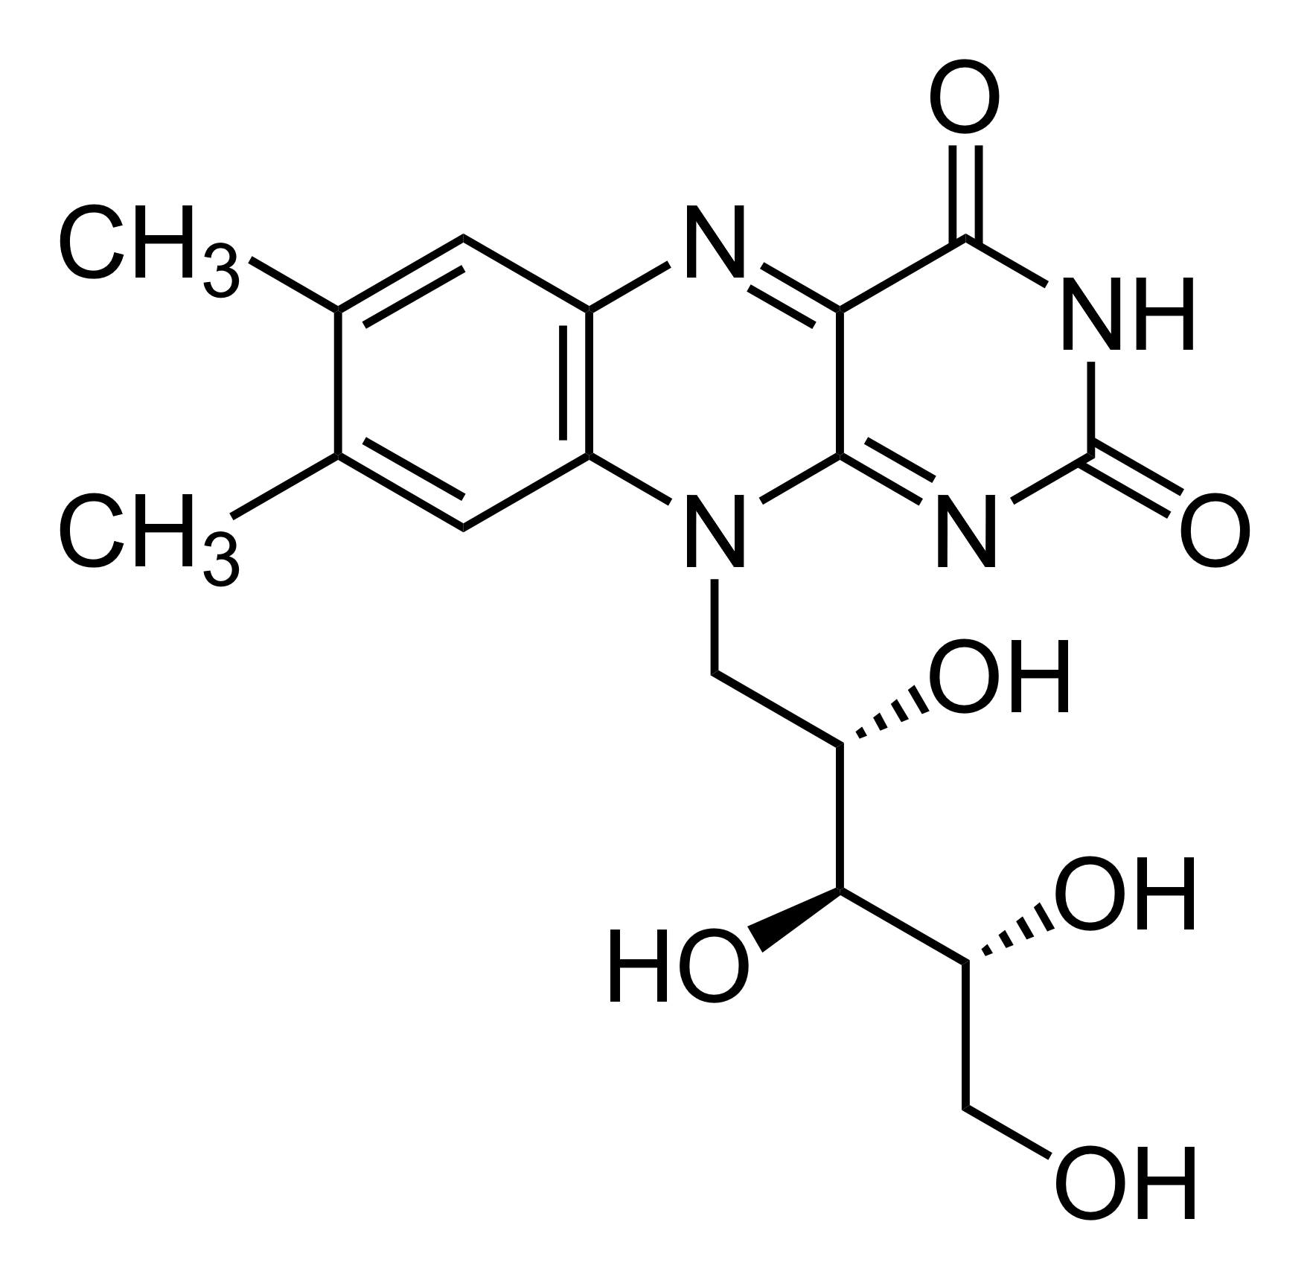

Figure 1. Chemical structure of riboflavin.

Question 2 (7 marks)
Ironman events include a 3.86 km swim, a 180.25 km bicycle ride and a 42.20 km run. It took the athlete Julian 12 hours and 35 minutes to complete the entire event. Throughout the event he used 1000 kilojoules of energy per hour.
- An energy bar contains 70 g of carbohydrates, of which 25 g is present as glucose. Describe why it is essential that athletes consume foods with high amounts of carbohydrates.
In your answer:
- give the thermochemical equation for cellular respiration, in kJ.mol⁻¹, if the respiration of glucose releases 15.88 kJ.g⁻¹
- provide the number of energy bars that is required by Julian. (4 marks)

- Glucose is a suitable source of carbohydrates during a race as it provides a quick release of energy. However, for daily consumption, nutritionists recommend more complex carbohydrate sources such wholemeal bread. Explain. (3 marks)

Question 3 (7 marks)
Linolenic acid is an omega 3 fatty acid, which is found in many foods including flax seeds.
- Linolenic is an essential fatty acid while arachidonic is a non-essential omega 6 fatty acid. Compare the structures and the physical properties of linolenic and arachidonic fatty acids.
In your answer:
- describe the structural differences between linolenic acid and arachidonic acid
- explain why one is known as an essential fatty acid and the other non-essential.
- predict whether linolenic or arachidonic fatty acid will have the lowest melting point. Justify your answer. (4 marks)

- Vegetable oils such as flaxseed oil contain high amounts of polyunsaturated fatty acids. One of the disadvantages of these types of oils is that they can easily become rancid. Demonstrate your understanding of the chemistry of this process.
In your answer:
- give an example of a chemical reaction that leads to oxidative rancidity
- identify the molecules that are predominantly responsible for the bad smelling odours in rancid oils.
- Identify a method that can be used slow the rate of rancidity and describe how it works. (3 marks)

Question 4 (7 marks)
A research scientist compared two methods of calibration of a solution calorimeter. In the first method they used electrical calibration while in the second method they used chemical calibration where the temperature change produced by the known reaction is used to determine the heat capacity of the calorimeter.
They obtained a calibration factor of 435 J.ºC⁻¹ using the electrical calibration method while they obtained a calibration factor of 315 J.ºC⁻¹ from using the heat of neutralisation of hydrochloric acid with sodium hydroxide.
The research scientist poured in 100 mL of water and added 3.2 g of potassium nitrate with stirring. The scientist measured a decrease in temperature of 2.7ºC.
- A standard table states that the heat of solution for potassium nitrate is +34.89 kJ.mol⁻¹. Use your understanding of calorimetry to identify the calibration method will result in the most accurate result.
In your answer:
- provide evidence to justify your response
- outline an error that lead to the overestimation or underestimation of the heat of solution of potassium nitrate. (4 marks)

- In further experiments the scientist proved that the combustion of the amino acid, glutamine, released the same amount of energy in both acidic or basic conditions. Explain this key finding.
In your answer, show the structure of glutamine in both acidic and basic conditions. (3 marks)

