CH₄ | Class: Alkane  FG: none  N: methane
CH₃OH | Class: Alkanol  FG: Hydroxyl or hydroxyl  N: methanol
CH₃CH₂COOH | Class: Carboxylic acid  FG: carboxyl or carboxy  N: propanoic acid
CH₃COOCH₂CH₃ | Class: Ester  FG: ester  N: ethyl ethanoate
CH₃COCH₃ | Class: Ketone  FG: carbonyl  N: propanone
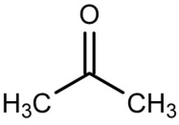 | Class: Ketone  FG: carbonyl  N: propanone
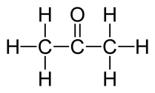 | Class: Ketone  FG: carbonyl  N: propanone
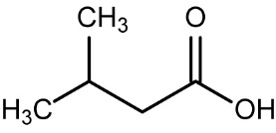 | Class: Carboxylic acid  FG: carboxyl or carboxy  N: 3-methyl butanonic acid
 | Class: Carboxylic acid  FG: carboxyl or carboxy  N: 3-methyl butanonic acid
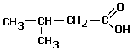 | Class: Carboxylic acid  FG: carboxyl or carboxy  N: 3-methyl butanonic acid
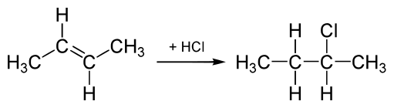 | Class: haloalkane  FG: chloro  N: 2 – chloro butane
Class: alkene
FG: double bond
N: but – 2 - ene
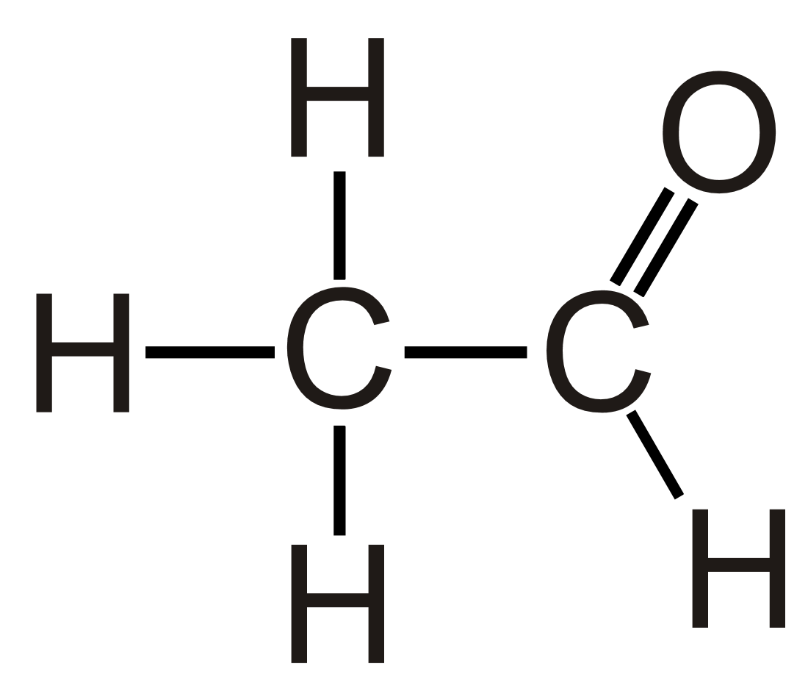 | Class: aldehyde  FG: carbonyl  N: ethanal
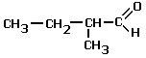 | Class: aldehyde  FG: carbonyl  N: 2 – methyl butanal
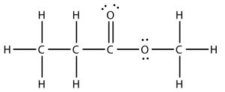 | Class: Ester  FG: ester  N: methyl propanoate
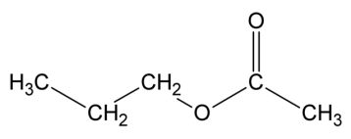 | Class: Ester  FG: ester  N: propyl ethanoate

