 |  | Notification of Assessment
Title of Assessment:
Subject Name: Chemistry Teacher(s) Name: Mitchell Hayes/ Kshitija Dhuna
Unit: 3 Area of Study: 1
Date and Lesson: |  |  | Task Type & Structure:
Date / Day: 7/5/2024 / Tuesday  Time of Day: 3:30 pm  Room: B28/B29 |  |  | Task Type: Written response  Number of Questions / Criteria: 3  Number of Marks: 40
Duration: 60 minutes |  |  | Submission:
Reading Time: 5 minutes  Writing Time: 55 minutes |  |  | Hand written documents
Conditions:
Students are NOT permitted to bring mobile phones and/or any other unauthorized electronic devices into the examination room.
All written responses must be in English.
Place the answer sheet for multiple-choice questions inside the front cover of this book.
Students are NOT permitted to bring into the examination room: blank sheets of paper, written material and/or correction fluid/tape or white out.
Materials/Equipment:
Chemistry Data Booklet
Scientific calculator
Contribution to Final Assessment:
Year 12:
This task will contribute 40 out of 80 marks allocated to School Assessed Coursework for Unit 3. This result is provisional only. The total result for all School Assessed Coursework in a Study will be statistically moderated against the November exam result.
This task will contribute evidence toward an S or N determination for Unit 3.
Absence:
Authorised absences from an assessment are those due to illness (with a medical certificate) or other special circumstances. An alternate assessment will be provided and completed during an afterschool session. A grade will be given for this alternate task. In the event of an unauthorised absence, a score of 0 will be given. The alternate assessment will still be completed to satisfy the outcomes covered.
Student Declaration:
I declare that all resource materials and assistance used have been acknowledged in accordance with VCAA rules and that all unacknowledged work is my own. I will not discuss the assessment with other students until it is handed back.
Student Name:
Student Signature: |  |  |  | Date: | / / 2024

Outcome/s (from the Study Design)
Compare fuels quantitatively with reference to combustion products and energy outputs, apply knowledge of the electrochemical series to design, construct and test primary cells and fuel cells, and evaluate the sustainability of electrochemical cells in producing energy for society.
Below are the key skills and knowledge that will be assessed (from the Study Design):
- redox reactions as simultaneous oxidation and reduction processes, and the use of oxidation numbers to identify the reducing agent, oxidising agent and conjugate redox pairs
- the writing of balanced half-equations (including states) for oxidation and reduction reactions, and the overall redox cell reaction in both acidic and basic conditions
- the common design features and general operating principles of non-rechargeable (primary) galvanic cells converting chemical energy into electrical energy, including electrode polarities and the role of the electrodes (inert and reactive) and electrolyte solutions (details of specific cells not required)
- the use and limitations of the electrochemical series in designing galvanic cells and as a tool for predicting the products of redox reactions, for deducing overall equations from redox half-equations and for determining maximum cell voltage under standard conditions
- the common design features and general operating principles of fuel cells, including the use of porous electrodes for gaseous reactants to increase cell efficiency (details of specific cells not required)
- contemporary responses to challenges and the role of innovation in the design of fuel cells to meet society’s energy needs, with reference to green chemistry principles: design for energy efficiency, and use of renewable feedstocks
- models and theories and their use in organising and understanding observed phenomena and chemical concepts including their limitations.

Preparation:
This is a list of pre-tasks students should have done that directly relate to the assessment.
- U3 AOS1 SAC Checklist (Attached here)
- Edrolo Lessons 3A-E & 3G
- Heinemann Chapters 4 & 5
- Revision booklet and solutions (OneNote)
- Worksheets on OneNote

Unit 3 AOS 1: A comparison of two electricity-generating cells

Scope of Assessment

Unit 3 AOS1
On completion of this unit the student should be able to compare fuels quantitatively with reference to combustion products and energy outputs, apply knowledge of the electrochemical series to design, construct and test primary cells and fuel cells, and evaluate the sustainability of electrochemical cells in producing energy for society.
Task Outline
A comparison of two electricity-generating cells.
SAC conditions
- The SAC will be completed under test conditions.
- Time allocation: 60 minutes
Marking Criteria: 40 marks allocated
- 40 marks are allocated for the inclusion of chemical concepts the key knowledge descriptors and key science skills. All answers must refer to the information provided in the question. No marks will be awarded for general answers.
- Students are expected to incorporate the skills listed on the rubric. The marks are not included in the total score but feedback will be provided.

Question 1
Scientists at Aitken University's Green Electrochemistry Labs are developing low-cost, eco-friendly galvanic cells. Aluminium, a lightweight, non-toxic, and recyclable metal, stands out for its high energy density and stability, making it a promising candidate.
The research team is constructing air-based galvanic cells, utilising aluminium (Al) in one half cells and oxygen in the other. The Al³⁺(aq)/Al(s) half-cell operates under standard laboratory conditions (SLC) with the following reaction:
Al³⁺(aq) +3e−→Al(s) E∘=−1.66V
The aluminium electrode pairs with an oxygen half-cell in a KOH electrolyte, generating a steady voltage for portable energy applications. Over time, harmless white Al (OH)₃ precipitate may form, while the solution remains clear.
Using the provided information, the scientists at Aitken University are constructing an aluminium-air galvanic cell to evaluate its feasibility in off-grid power supplies and electric vehicle range extenders
a) Fill in Table 1 for the galvanic cell outlined above. (7 marks)
Table 1
i. Is the positive (+) electrode the cathode or anode?
ii. Write the half equation for the reduction reaction.
iii. Write the half equation for the oxidation reaction.
iv. Calculate the cell voltage.
v. Give the direction of the flow of the anions in the salt bridge.

B.
A group of chemistry students from Aitken College is investigating the properties of an aluminium-air galvanic cell. The cell consists of an Al(s)/Al³⁺(aq) half-cell and an oxygen half-cell in a KOH electrolyte. The setup is placed in a transparent battery case to observe changes during operation.
      - Diagram Requirements:
Label the components of both half-cells, including:
• The metal electrode (Aluminium anode) and ions (Al³⁺ in solution).
• The oxygen cathode and relevant ions in the electrolyte.
• The KOH electrolyte and its role in ion transport.
      - Indicate the direction of electron flow in the external circuit with an arrow.
      - Observations:
a. At the anode: Describe changes to the aluminium electrode or solution.
b. At the cathode: Describe changes in the oxygen electrode or electrolyte solution
iv. Overall Reaction:
Write the balanced redox equation for the aluminium-air battery, including the standard cell potential (E°).

Diagram (Annotated)

Direction of electron flow

Observations in both half-cells

Write the Overall Reaction with E⁰ value of the Jaqium-Zinc cell

C.
A group of students tested different half-cell combinations for an aluminium-air cell to determine the voltage ranking when paired with the Al³⁺(aq)/Al(s) half-cell, where Al(s) acts as the anode.
The half-cells tested were:
- Fe²⁺(aq)/Fe(s)
- Sn²⁺(aq)/Sn(s)
- Co²⁺(aq)/Co(s)
What would be the best ranking of these half-cells from highest to lowest voltage when combined with the aluminium half-cell? Explain your answer using the electrochemical series in your Data Booklet.

Question 2 (18 marks)
Fuel cells are typically powered by hydrogen, often produced from methane through an expensive process called reforming. However, the CSSFC (Carbon Superstructure Solid Fuel Cell), developed in Prof Yan Hang Hu’s lab, can directly use methane as a fuel. This innovation offers fuel flexibility and operates efficiently at lower temperatures, as low as 470°C, due to its superstructure electrolyte, unlike conventional solid oxide fuel cells that require over 800°C. The direct oxidation of methane by oxygen flux is given as:
CH₄ (g) + 4O²⁻ (aq) CO₂ (g) + 2H₂O (l) + 4e-

a) Label the diagram of the CSSFC given below with the following information: (4 marks)
- The reactants CH₄ and O₂. (1)
- The direction of electron flow. (1)
- The half-equation for the reduction reaction. (1)
- The anode and the cathode (1)

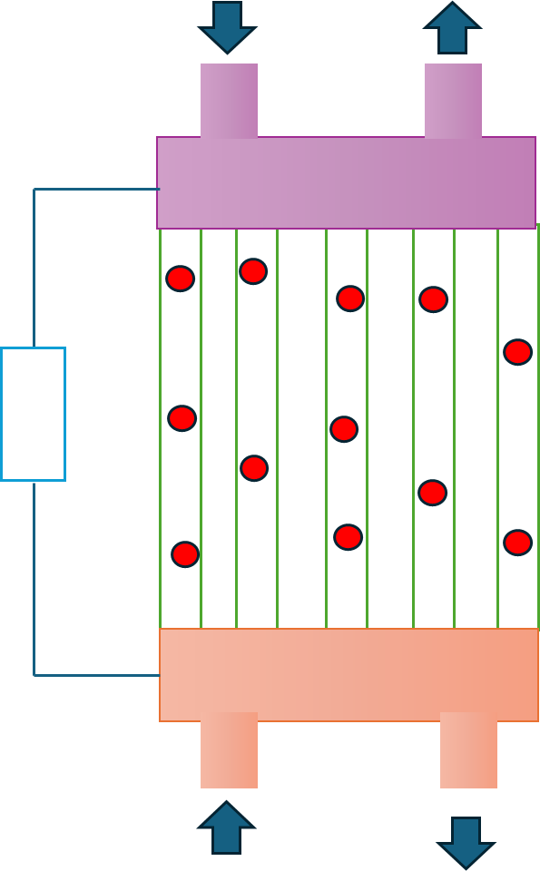

Note: In carbonate-superstructured SOFCs, molten carbonate in the porous electrolyte enhances oxygen ion flow to the fuel by creating a smooth, continuous interface. The carbonate does not react with the fuel but reduces resistance and improves the connection between the electrode and electrolyte.

- Compare the Al- air galvanic cell described in Question 1 with the CSSFC Fuel Cell from Question 2.
  - Identify two differences between the two types of cells being discussed. For each of these differences consider which cell would be more suitable for their use as a power supply for an army trolley used for transporting supplies to an army camp in the Blue Mountains National Park, Sydney. (4 marks)
___________________________________________________________________________________
___________________________________________________________________________________
___________________________________________________________________________________
___________________________________________________________________________________
___________________________________________________________________________________
___________________________________________________________________________________
___________________________________________________________________________________
c) Identify one hazard/concern regarding the use of CSSFC Fuel Cells in the batteries of light-duty vehicles. State a precaution that can be used to minimise the risk for these cells.
(2 marks)
Table 2
Cell | Hazard | Precaution
CSSFC Fuel cell

d) One design feature of each cell is listed below. State why these features are important for the correct functioning of the cells in electric cars.
- Al_{(s)}/Al³⁺_{(aq)} and O_{2(g)}/OH- (aq) cell
Design feature: Half cells are connected by a salt bridge. (2 marks)
___________________________________________________________________________________
___________________________________________________________________________________
___________________________________________________________________________________
___________________________________________________________________________________
- CSSFC fuel cell
Design feature: A central cavity containing an electrolyte. (2 marks)
___________________________________________________________________________________
___________________________________________________________________________________
___________________________________________________________________________________
___________________________________________________________________________________

Question 3 (13 marks)
Microbial Fuel Cells (MFCs) are an alternative to conventional fuel cells that can treat wastewater while simultaneously generating small amounts of electricity at ambient temperatures. The energy efficiency of MFCs is lower than that of fuel cells, being 35% and 60% respectively. Despite this, the electricity produced is enough to power small electronic devices, such as environmental monitoring sensors. MFCs use bacteria to break down a range of organic matter to generate electricity.

One organic molecule that can be processed in MFCs is acetate, the reaction observed at the anode and the structure of this fuel cell is shown below:

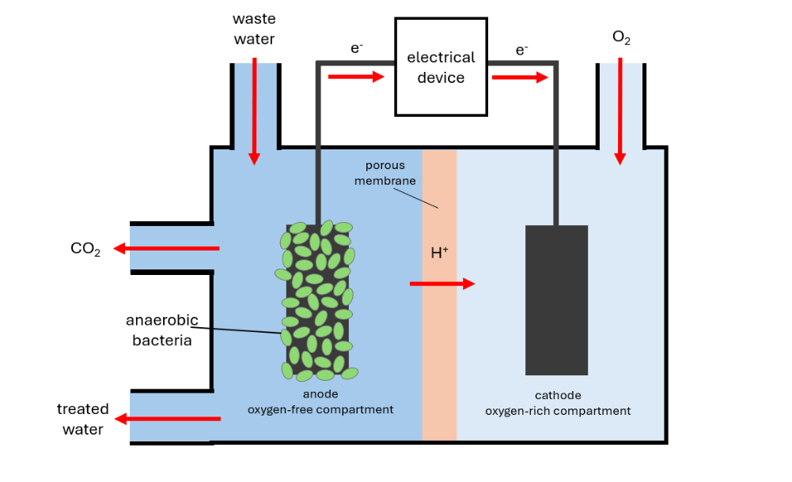
C₂H₃COO⁻_{(aq)} + 2H₂O_{(l)} à 2CO₂ + 7H⁺ + 8e⁻

^{Reference}
  - Use the half equation given above to identify the oxidation number of carbon atoms in both the reactant and product species. (2 marks)
____________________________________________________________________________________
____________________________________________________________________________________
____________________________________________________________________________________
____________________________________________________________________________________
____________________________________________________________________________________
  - Justify whether the carbon in acetate is oxidised or reduced. (2 mark)
____________________________________________________________________________________
____________________________________________________________________________________
____________________________________________________________________________________
  - A rural NSW farm is struggling with severe water drought. Land runoff upstream has contaminated creek water, causing excessive organic material and algae growth, which makes this water unsuitable for agricultural use. To address this issue, the farmer plans to install fixed water sensors to monitor pollutants in the water continuously.
The latest MFC unit on the market, the MFC 300, is being considered by the farmer to power these sensors. Each unit can provide a voltage of 300 mV and they may be stacked in series to increase the sum of their total voltage output.
      - Suggest two advantages of using MFCs to power these sensors over primary galvanic cells. (2 marks)
____________________________________________________________________________________
____________________________________________________________________________________
____________________________________________________________________________________
____________________________________________________________________________________
      - The farmer is also considering using MFC 300s to power an electric water pump near a large dam on the property. The voltage requirement of this pump is 14 V. P
How many MFC300 units would be needed to supply the water pump with sufficient voltage?
(2 marks)
____________________________________________________________________________________
____________________________________________________________________________________
____________________________________________________________________________________
____________________________________________________________________________________
____________________________________________________________________________________
      - Explain why environmentalists are not concerned about the CO₂ produced by MFCs contributing to the greenhouse effect. (1 mark)
____________________________________________________________________________________
____________________________________________________________________________________
____________________________________________________________________________________
____________________________________________________________________________________
      - Evaluate the applicability of MFCs and PEMFCs for powering electronic equipment on the farm. In your answer refer to the two green chemistry principles below (refer to p.23 of data booklet for more information). (4 marks)
Design for energy efficiency.
Use of renewable feedstocks.
____________________________________________________________________________________
____________________________________________________________________________________
____________________________________________________________________________________
____________________________________________________________________________________
____________________________________________________________________________________
____________________________________________________________________________________
____________________________________________________________________________________
____________________________________________________________________________________
____________________________________________________________________________________
____________________________________________________________________________________

END OF SAC

