Unit 4 Area of Study 2 Key Knowledge

Laboratory analysis of organic compounds
- qualitative tests for the presence of carbon-carbon double bonds, hydroxyl and carboxyl functional groups
- applications and principles of laboratory analysis techniques in verifying components and purity of consumer products, including melting point determination and distillation (simple and fractional)
- measurement of the degree of unsaturation of compounds using iodine
- volumetric analysis, including calculations of excess and limiting reactants using redox titrations (excluding back titrations)

Instrumental analysis of organic compounds
- applications of mass spectrometry (excluding features of instrumentation and operation) and interpretation of qualitative and quantitative data, including identification of molecular ion peak, determination of molecular mass and identification of simple fragments
- identification of bond types by qualitative infrared spectroscopy (IR) data analysis using characteristic absorption bands
- structural determination of organic compounds by low resolution carbon-13 nuclear magnetic resonance (¹³C-NMR) spectral analysis, using chemical shift values to deduce the number and nature of different carbon environments
- structural determination of organic compounds by low and high resolution proton nuclear magnetic resonance (¹H-NMR) spectral analysis, using chemical shift values, integration curves (where the height is proportional to the area underneath a peak) and peak splitting patterns (excluding coupling constants), and application of the n+1 rule (where n is the number of neighbouring protons) to deduce the number and nature of different proton environments
- the principles of chromatography, including high performance liquid chromatography (HPLC) and the use of retention times and the construction of a calibration curve to determine the concentration of an organic compound in a solution (excluding features of instrumentation and operation)
- deduction of the structures of simple organic compounds using a combination of mass spectrometry (MS), infrared spectroscopy (IR), proton nuclear magnetic resonance (¹H-NMR) and carbon-13 nuclear magnetic resonance (¹³C-NMR) (limited to data analysis)
- the roles and applications of laboratory and instrumental analysis, with reference to product purity and the identification of organic compounds or functional groups in isolation or within a mixture

Medicinal chemistry
- extraction and purification of natural plant compounds as possible active ingredients for medicines, using solvent extraction and distillation
- identification of the structure and functional groups of organic molecules that are medicines

Unit 4 AOS 1 How are organic compounds analysed and used?
Type of SAC: analysis and evaluation of a chemical innovation, research study, case study, socio-scientific issue, or media communication.

Panax ginseng (C.A. Meyer) is a perennial herb that has been highly regarded in traditional medicine for centuries in Southeast Asian countries due to its revitalising properties [1]. Since the 1970s, modern research has aimed to uncover the pharmacological mechanisms behind ginseng’s effects, although its full medicinal potential remains only partially understood. Often known as a “cure-all” potion, Panax ginseng has been found to have bioactive components called ginsenosides which target specific receptors in the body to alleviate inflammation, ageing and even cancer [2,3].
Fig 1. Dried root of Panax ginseng
Traditionally, ginseng is consumed as a tea, in soups, wine and even chewed raw. At the industrial level, ginseng extract is conventionally obtained by extracting raw ginseng or dried ginseng powder with ethanol and then mechanically pressing the mixture. The solid content ratio is between 21% and 27%. This method is time-consuming and has a low yield. To circumvent this issue, a Japanese team led by Toshio Chin has invented a new method of extraction (Patent Pending). The method involves the use of enzymes cellulase and pectinase (break down of cell wall). The left panel shows the step wise extraction procedure
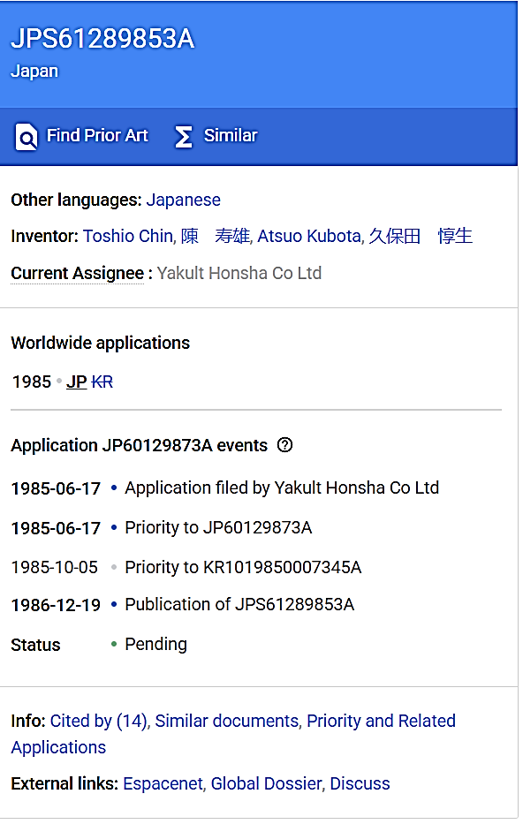
Fig 2. Patent Application for the enzymatic extraction method of Panax ginseng [4].
Raw Material Selection
Use either raw Panax ginseng or dried Panax ginseng (preferred for uniformity).

Powder Preparation (if using dried Panax ginseng)
Grind into uniform powder (preferred for uniformity).

Swelling (if using dried Panax ginseng)
Heat powder in boiling water (~10 min) to enhance enzyme penetration.
(preferred for uniformity).

Enzymatic Treatment
Suspend crushed or swollen Panax ginseng in ~5x volume of water.
Add enzyme (1.0-4.0% of dried material, preferably 1.25%) (preferred for uniformity).

Extraction Process
Allow enzymatic reaction under stable conditions.
(preferred for uniformity).

Question 1
- Using your understanding of extraction and purification of medicinal compounds, compare and contrast the enzymatic extraction method outlined in the patent above with the conventional solvent extraction method, where ethanol is used to extract Panax ginseng through heat reflux or Soxhlet extraction, typically repeated multiple times at high temperatures (around 90°C) to maximize the extraction of ginsenosides.

- A patent application has been submitted for the enzymatic extraction method, and approval is currently pending. In this context, explain how this method aligns with green chemistry principles, making it a more sustainable and environmentally friendly alternative to conventional solvent extraction, thereby strengthening its case for patent approval.

Question 2
- The conventional method for extraction of Panax ginseng involves steaming, which breaks down complex organic compounds into simpler metabolites. How can qualitative tests be used to identify the presence of acids, esters, and alkenes in extracts obtained through different extraction methods?

Question 2 (cont…)
- The students anticipate the formation of either malic acid or citric acid as a result of steaming. They send the extract for mass spectrometry analysis and receive the following spectrogram.
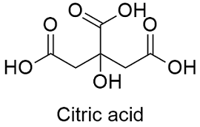
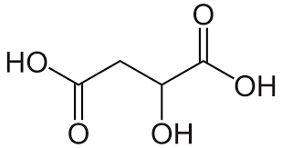
Citric acid (C₆H₈O₇)

Malic acid (C₄H₆O₅)

Based on the data, answer the following questions to determine which acid may be present.
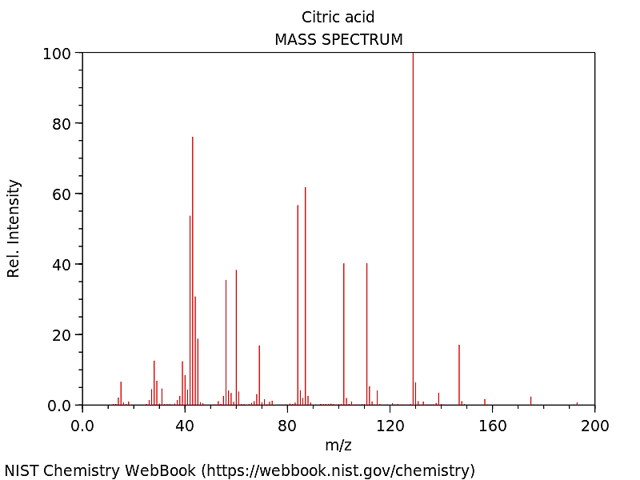

What conclusion can the students draw from the information provided in the spectrogram?
- What conclusion can the students draw from the information provided in the infra-red spectrogram?
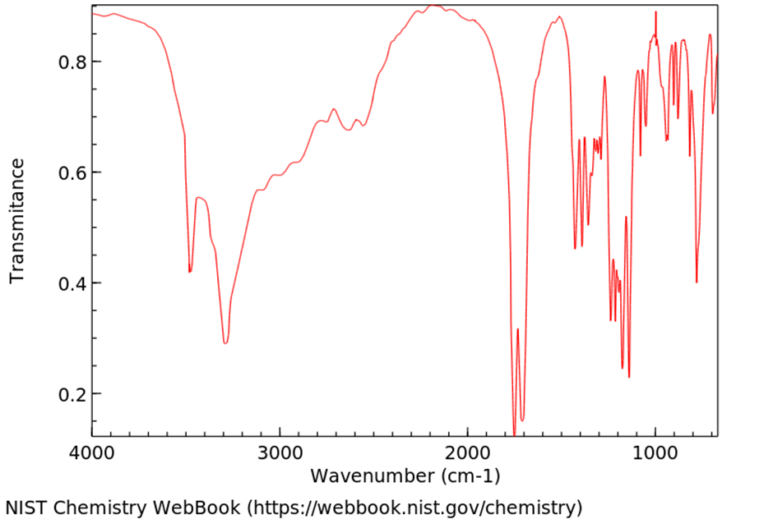

Question 3
Malic acid is found in apples, while citric acid is present in oranges. Hypothetically, is it feasible for students to synthesise sweet-smelling esters by reacting alcohols with one of these acids? If so, provide a balanced chemical equation, including the structural formula of the chosen acid and alcohol, to illustrate the esterification reaction.

The overall yield of Panax ginseng extract is low using the conventional methods. Therefore, efforts are made to know the exact quantity of each ginsenoside in the extract. An important compound call has potent medicinal properties and was found in the extract. To find out the exact concentration of CK in the sample, HPLC was performed using standard concentrations to obtain a standard curve. The peak areas on the chromatogram are given here.
Compound K Standard (µg mL⁻¹) | Peak area (mm²)
0.0 | 0
0.5 | 6.2
1.0 | 11.4
1.5 | 16.9
2.0 | 22.0
1 mL of the CK sample was diluted from to 1L. It was found that the peak area of this sample was 13.5 mm².
Construct a calibration curve on the grid below. (2 marks)

- Calculate the concentration of Compound K in the original sample. Indicate on the graph where you have done this. (2marks)

Question 4

If there is an alcohol contamination in the sample, suggest the expected observations on the following spectrum if ethanol was found to be present within the sample of the organic acid in Q 2?
- Mass spectrum.
- IR spectrum.

- CHOI K. Botanical characteristics, pharmacological effects and medicinal components of Korean Panax ginseng C A Meyer. Acta Pharmacologica Sinica. 2008 Sep;29(9):1109–18.
- Dhuna K, Felgate M, Bidula SM, Walpole S, Bibic L, Cromer B, et al. Ginsenosides act as positive modulators of P2X4 receptors. figshare [Internet]. 2019 Feb [cited 2025 Feb 12]; Available from: https://figshare.swinburne.edu.au/articles/journal_contribution/Ginsenosides_act_as_positive_modulators_of_P2X4_receptors/26249669?file=48202759
- Kim S, Kim N, Jeong J, Lee S, Kim W, Ko SG, et al. Anti-Cancer Effect of Panax Ginseng and Its Metabolites: From Traditional Medicine to Modern Drug Discovery. Processes. 2021 Jul 30;9(8):1344–4.
- JPS61289853A - Extraction of panax ginseng extract - Google Patents [Internet]. Google.com. 1985 [cited 2025 Feb 12]. Available from: https://patents.google.com/patent/JPS61289853A/en

