12 Chemistry Unit 3 AOS2 Rate and extent of chemical reactions

Scope of Assessment

Unit 3 AOS2
Experimentally analyse chemical systems to predict how the rate and extent of chemical reactions can be optimised

Task Outline
Analysis and evaluation of primary and/or secondary data, including identified assumptions or data limitations, and conclusions

SAC conditions
- The SAC will be completed under test conditions with a time allocation of 50 minutes.

Relevant Key knowledge descriptors

Rates of chemical reactions
- factors affecting the frequency and success of reactant particle collisions and the rate of a chemical reaction in open and closed systems, including temperature, surface area, concentration, gas pressures, presence of a catalyst, activation energy and orientation
- the role of catalysts in increasing the rate of specific reactions, with reference to alternative reaction pathways of lower activation energies and represented using energy profile diagrams

Extent of chemical reactions
- the distinction between reversible and irreversible reactions, and between rate and extent of a reaction
- the dynamic nature of homogenous equilibria involving aqueous solutions or gases, and their representation by balanced chemical or thermochemical equations (including states) and by concentration-time graphs
- the change in position of equilibrium that can occur when changes in temperature or species or volume (concentration or pressure) are applied to a system at equilibrium, and the representation of these changes using concentration-time graphs
- the application of Le Chatelier’s principle to identify factors that favour the yield of a chemical reaction
- calculations involving equilibrium expressions (including units) for a closed homogeneous equilibrium system and the dependence of the equilibrium constant (K) value on the system temperature and the equation used to represent the reaction
- the reaction quotient (Q) as a quantitative measure of the extent of a chemical reaction: that is, the relative amounts of products and reactants present during a reaction at a given point in time
- responses to the conflict between optimal rate and temperature considerations in producing equilibrium reaction products, with reference to the green chemistry principles of catalysis and designing for energy efficiency

Relevant key science skills
- identify, research and construct aims and questions for investigation
- identify independent, dependent and controlled variables in experiments
- formulate hypotheses to focus investigations
- identify and analyse experimental data qualitatively, handling, where appropriate, concepts of: accuracy, precision, repeatability, reproducibility, resolution, and validity of measurements; and errors (random and systematic)
- analyse and explain how models and theories are used to organise and understand observed phenomena and concepts related to chemistry, identifying limitations of selected models/theories
- apply sustainability concepts (green chemistry principles, development goals and the transition from a linear towards a circular economy) to analyse and evaluate responses to chemistry-based scenarios, case studies, issues and challenges

Marking Criteria: 40 marks allocated
- 40 marks are allocated for inclusion of chemical concepts the key knowledge descriptors and key science skills. All answers must refer to the information provided in the question. No marks will be awarded for general answers.

Question 1 (20 marks)
The demand for hydrogen gas produced from renewable sources is predicted to increase significantly in the next five years. A process which is currently being investigated is the sulphur-iodine thermochemical cycle where sulphuric acid and hydrogen iodide is decomposed to form oxygen and hydrogen gas.
The sulphur-iodine thermochemical cycle is divided into three equilibrium reactions with the chemical equation and possible reaction conditions for the first reaction given below:
Reaction equation 1 I₂ + SO₂ + 2H₂O $↔$ 2HI + H₂SO₄ △H = -75 kJ.mol⁻¹
Possible operating temperatures: 0 – 120ºC

Write a report discussing the conditions which should be employed to achieve the optimal yield and reaction rate.
In your report you should
- explain how temperature, surface area, concentration, gas pressure and catalysts will affect the yield and reaction rate.
- evaluate how your design will minimise energy use, discussing the conflicts between achieving the optimal conditions and the energy required to achieve these conditions.
- justify your selected reaction conditions by referring to collision theory and Le Chatelier’s principle.

_____________________________________________________________________________________________________________________________________________________________________________________________________________________________________________________________________________________________
_____________________________________________________________________________________________________________________________________________________________________________________________________________________________________________________________________________________________
_____________________________________________________________________________________________________________________________________________________________________________________________________________________________________________________________________________________________
_____________________________________________________________________________________________________________________________________________________________________________________________________________________________________________________________________________________________
_____________________________________________________________________________________________________________________________________________________________________________________________________________________________________________________________________________________________
______________________________________________________________________________________________________________________________________________________________________________________________
_____________________________________________________________________________________________________________________________________________________________________________________________________________________________________________________________________________________________
_____________________________________________________________________________________________________________________________________________________________________________________________________________________________________________________________________________________________
_____________________________________________________________________________________________________________________________________________________________________________________________________________________________________________________________________________________________
_____________________________________________________________________________________________________________________________________________________________________________________________________________________________________________________________________________________________
_____________________________________________________________________________________________________________________________________________________________________________________________________________________________________________________________________________________________
______________________________________________________________________________________________________________________________________________________________________________________________
_____________________________________________________________________________________________________________________________________________________________________________________________________________________________________________________________________________________________
_____________________________________________________________________________________________________________________________________________________________________________________________________________________________________________________________________________________________
_____________________________________________________________________________________________________________________________________________________________________________________________________________________________________________________________________________________________

Question 2 (20 marks)
The final equilibrium reaction in the sulphur-iodine thermochemical process is the decomposition of hydrogen iodide to form hydrogen and iodine.
Reaction equation 3 2HI $↔$ H₂ +. I₂ △H = +12 kJ.mol⁻¹
Operating temperature 450°C
A research student used data simulation software to investigate the effect on the yield when hydrogen iodide is periodically injected into the reaction vessel.
At the beginning of the experiment, they injected 2 moles of hydrogen iodide into the 1 L reaction vessel at a temperature of 450ºC and 100 kPa. They collected their data every 7.5 minutes for 45 minutes and plotted the decomposition of HI and the formation of H₂ and I₂ on a concentration time graph (see below). Note that the data for the production of iodine and hydrogen is overlapping.
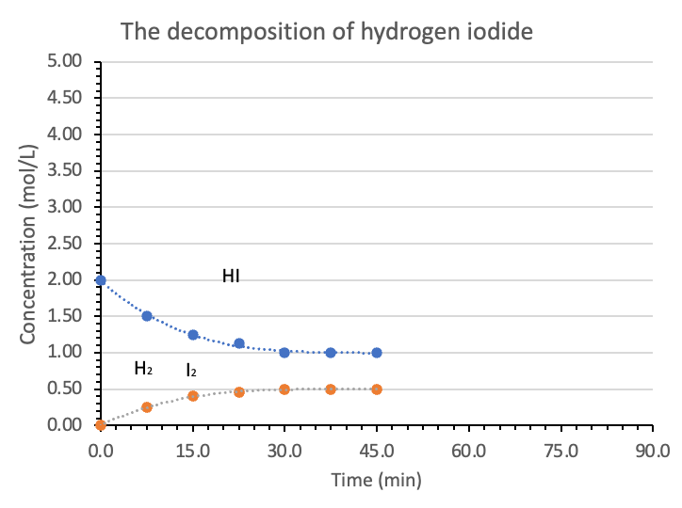
- Identify the independent variable and the dependent variable for the investigation. 2 marks
_________________________________________________________________________________________
- The student calculated that the value of the reaction quotient at 15 minutes was 0.102. Calculate the equilibrium constant after the first HI injection and compare this with the reaction quotient. Comment on how the ratio of products to reactants changes as the reaction approaches equilibrium. 3 marks
________________________________________________________________________________________________________________________________________________________________________________________________________________________________________________________________________
________________________________________________________________________________________
________________________________________________________________________________________________________________________________________________________________________________
- At 45 minutes, the student injected another 2 moles of hydrogen iodide into the reaction vessel. On the graph above, draw the expected change in concentration of the species in the reaction vessel. 4 marks
- Write a statement summarising the key finding for the investigation and explain your finding using scientific theory. 2 marks
________________________________________________________________________________________________________________________________________________________________________________________________________________________________________________________________________________________________________________________________________________________________________________________________________________________________________________________________________________________________________________________________________________________________________________________________________________________________________________________________________________________________________________________________________________________________________________________________________________________
- Comment on whether injecting hydrogen iodide, HI, into the reaction vessel every 45 minutes is an effective way to change the yield of the reaction. Suggest an alternative method. 3 marks
________________________________________________________________________________________________________________________________________________________________________________________________________________________________________________________________________________________________________________________________________________________________________________________________________________________________________________________________________________________________________________________________________________________________________________________________________________________________________________________________________________________________________________________________
- Comment on the limitations of this investigation and make recommendations for further research. 3 marks
________________________________________________________________________________________________________________________________________________________________________________________________________________________________________________________________________________________________________________________________________________________________________________________________________________________________________________________________________________________________________________________________________________
- The student then completed an investigation into the effect of temperature on the reaction yield using the experimental set up shown below. In this system, the reaction vessel has a platinum catalyst and the temperature is measured using a thermocouple (T.C).

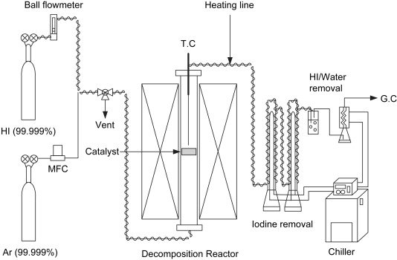
Temperature probe
Reference: Jung-Min Kim a, et al., (2008) Decomposition of hydrogen iodide on Pt/C-based catalysts for hydrogen production, International Journal of Hydrogen Energy, Volume 33, Issue 19, October 2008, Pages 4974-4980, www.sciencedirect.com, [date accessed 2nd June 2024].

Identify and explain how a component in the experimental set up could lead to systematic errors. 3 marks

________________________________________________________________________________________________________________________________________________________________________________________________________________________________________________________________________
________________________________________________________________________________________________________________________________________________________________________________________________________________________________________________________________________
________________________________________________________________________________________
________________________________________________________________________________________________________________________________________________________________________________________________________________________________________________________________________

End of SAC

