SAC 4.3 Student designed investigation

Scope of Assessment Name: __________________________________

Unit 4 AOS3
Design and conduct a scientific investigation related to the production of energy and/or chemicals and/or the analysis or synthesis of organic compounds, and present an aim, methodology and method, results, discussion and conclusion in a scientific poster.

Task Outline
The investigation involves the generation of primary data related to the content covered in either Unit 3 or 4 and be inspired by a contemporary chemical challenge or issue. When undertaking the investigation students are required to apply the key science skills to develop a question, state an aim, formulate a hypothesis and plan a course of action to answer the question, while complying with safety and ethical guidelines. Students then undertake an experiment to generate primary quantitative data, analyse and evaluate the data, identify limitations of data and methods, link experimental results to scientific ideas, discuss implications of the results, and draw a conclusion in response to the question. The presentation format for the investigation is a scientific poster constructed according to the structure provided below and has a maximum word limit of 600 words. A logbook needs to maintained by students for recording, assessment and authentication purposes.
The task is divided into three phases;
- Planning the experiment
- Conducting the experiment
- Communicating your findings in a scientific poster

SAC conditions
The planning, design and conduction of the experiment will take place over a number of lessons and the discussion will be written under test conditions in a 50 minute period. The poster will be collated in one lesson.

Relevant key knowledge descriptors

Investigation design
- chemical concepts specific to the selected scientific investigation and their significance, including definitions of key terms
- characteristics of the selected scientific methodology and method, and appropriateness of the use of independent, dependent and controlled variables in the selected scientific investigation
- techniques of primary quantitative data generation relevant to the selected scientific investigation
- the accuracy, precision, repeatability, reproducibility, resolution and validity of measurements
- the health, safety and ethical guidelines relevant to the selected scientific investigation

Scientific evidence
- the nature of evidence that supports or refutes a hypothesis, model or theory
- ways of organising, analysing and evaluating primary data to identify patterns and relationships, including sources of error and uncertainty
- authentication of generated primary data through the use of a logbook
- assumptions and limitations of investigation methodology and/or data generation and/or analysis methods

Science communication
- conventions of science communication: scientific terminology and representations, symbols, formulas, standard abbreviations and units of measurement
- conventions of scientific poster presentation, including succinct communication of the selected scientific investigation, and acknowledgements and references
- the key findings and implications of the selected scientific investigation

Timeline
Lesson | Content | Date
1 | Conductive biopolymer experiment | 19 Feb
2 | Catalase enzyme experiment | 20 Feb
3 | Research question, aim, variables and hypothesis | 28 Feb
4 | Materials, method, design results table, experimental log, risk assessment | 28 Feb
5 | Write introduction | 1 Mar
6 | Conduct experiment | 4 Mar
7 | Conduct experiment | 5 Mar
8 | Graph results, analyse data | 6 Mar
9 | Discussion plan | 8 Mar
10 | Write discussion under test conditions | 11 Mar
11 | Complete poster | 13 Mar

Required Poster Layout and Sections
The poster must be produced electronically and should not exceed 600 words. Supporting text, such as in tables, graphs, image captions, references and acknowledgements, is not included in the word count.
Posters needs to be written in a way that is concise, clear and legible. Students will use the scientific poster format given below when reporting on their investigation.
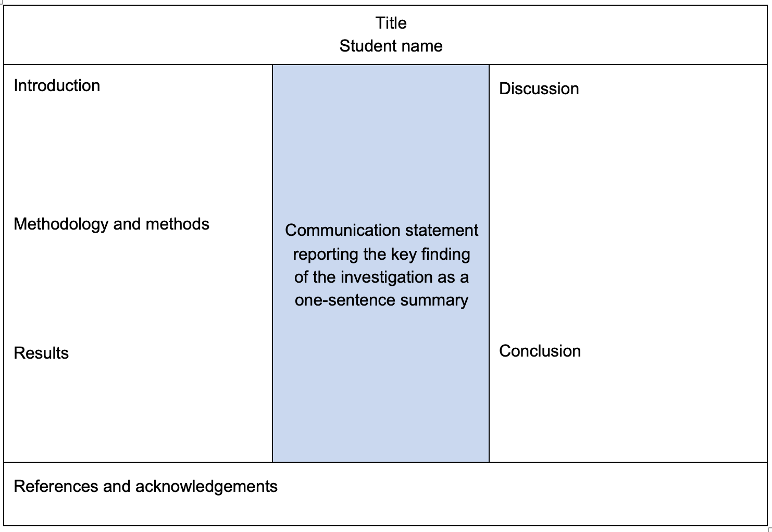
The centre of the poster will occupy between 20 to 25 per cent of the poster space and will be a one-sentence summary of the major finding of the investigation that answers the investigation question.

The presentation format of the poster will include the following sections.
Poster section | Content
Title | Question under investigation
Introduction | Brief explanation or reason for undertaking the investigation, including a clear aim, a hypothesis and/or prediction and relevant background chemical concepts
Methodology and methods | Brief outline of the selected methodology used to address the investigation question
Methodology and methods | Summary of data generation method(s) and data analysis method(s)
Results | Presentation of generated data/evidence in appropriate format to illustrate trends, patterns and/or relationships
Discussion | Interpretation and evaluation of analysed primary data
Discussion | Identification of limitations in data and methods, and suggested improvements
Discussion | Cross-referencing of results to relevant chemical concepts
Discussion | Linking of results to investigation question and to the aim to explain whether the investigation data and findings support the hypothesis
Conclusion |  | Conclusion that provides a response to the investigation question
 |  | Identification of the extent to which the analysis has answered the investigation question, with no new information being introduced
References and acknowledgements |  | Referencing and acknowledgement of all quotations and sourced content relevant to the investigation
Students record in their logbooks all elements of their investigation planning, comprising identification and management of relevant risks, recording of raw data, and preliminary analysis and evaluation of results, including identification of outliers and their subsequent treatment. Both the students’ poster and logbook entries are assessed as part of Unit 4, Area of Study 3.

Assessment Rubric
 | 1 | 2 | 3 | 4
Log book | lists materials and method | identifies hazards and devises safety precautions | records observations | creates reproducible method and observations
Designs investigation | distinguishes between factors to control, measure and change | designs a fair test with at least 5 controls | creates a hypothesis to predict outcome | hypothesis links independent and dependent variables
Introduces investigation | Identifies aim and hypothesis | describes context or problem with in-text citations | describes relevant background chemical concepts | evaluates how project extends understanding
Represents data | uses graph that follows some set conventions | designs graph which follows set conventions | creates graph which shows patterns and/or relationships
Reports data | includes relevant data | summarises data | describes the quality of the data using measurement terms | elaborates on the terms used to describe the quality of data
Analyses data | devises key finding related to the aim | explains key finding using a science theory with in-text citations | applies understanding of science theories to explain key finding | makes links to hypothesis and other science studies
Evaluates method | identifies limitations in data and methods | categorises errors as random or systematic | explains why errors occurred | evaluates how errors affect quality of data
Modifies method | identifies steps or equipment which can be modified | explains how modifications improve design | predicts the effect of modifications on the quality of data
Makes conclusions | summarises key findings | describes extent to which analysis answered research question | makes recommendations for further research to broaden application of key findings | evaluates the implications of the investigation to the wider community
Communicates ideas | follows required format for poster and meets 600 word limit | uses scientific conventions for units, labelling of figures and tenses | uses graphics to convey ideas | uses clear, coherent and concise expression within scientific writing
Bibliography | includes references | uses required referencing style

Selection of Topics
All students will work individually on their research projects. Selecting from two research topics, tissue engineering with conductive biopolymers and enzyme biosensors, students will design a unique research question with corresponding independent and dependent variables.

Topic 1: Tissue engineering with conductive biopolymers
Tissue engineering is an emerging medical field which aims to restore damaged tissue with the ultimate aim to be able to produce entire organs. One of the challenges of this field is that materials implanted into the body must be electrically conductive with the conductivity of tissues ranging between 0.03 and 0.6 S/m (where S = 1/ohms) and conductivity of heart muscle being 268 Ohms/cm. As biopolymer materials are mostly made of covalent compounds which are known to be non-conductive, recent research has focused on including electrically conductive materials.
In this research project, you will modify the base method in order to design an electrically conductive biopolymer.
The electrical conductivity can be increased by adding conductive materials such as:
1. Sodium chloride
2. Magnesium chloride
3. Lithium chloride
4. Graphite

Students will determine the conductivity of the biopolymer by measuring the resistance of the bioplastic and converting this to conductivity.

Gelatin Bioplastic

Materials

- shared water bath (70ºC)
- 250 mL beaker
- electronic scales
- spatula
- weigh tray
- deionised water
- glycerol
- ethanol (15% w/w)
- gelatine
- rectangle mould
- masking tape and pen

Procedure
- Put the 250mL beaker on the scales and tare the scales to 0 g.
- Add each of the following to the beaker:
- 50 g of deionised water,
- 10 g of 15 % w/w ethanol
- 9 g of glycerol.
- Weigh 12 g of gelatine in a weigh tray and slowly add to mixture, stirring with the spatula.
- Add your additive to the
- Place beaker in the water bath at 70ºC for 15 minutes. Stir occasionally.
- Pour the mixture into the mould.
- Put the bioplastic aside to set for 24 hours.
- When it is dry, remove the bioplastic, wrap in cling wrap, label with masking tape and place in the fridge.

Topic 2: Enzyme Biosensors
In the previous two decades, there has been much research into the use of enzyme biosensors as diagnostic tools in the fields of medicine, food safety and pollutant monitoring [1]. As enzymes facilitate specific reactions, biosensors have the advantage of being able to detect individual analytes within complex mixtures. One of the major challenges associated with this technique is that enzymes become inactive in high temperature or high or low pH conditions.
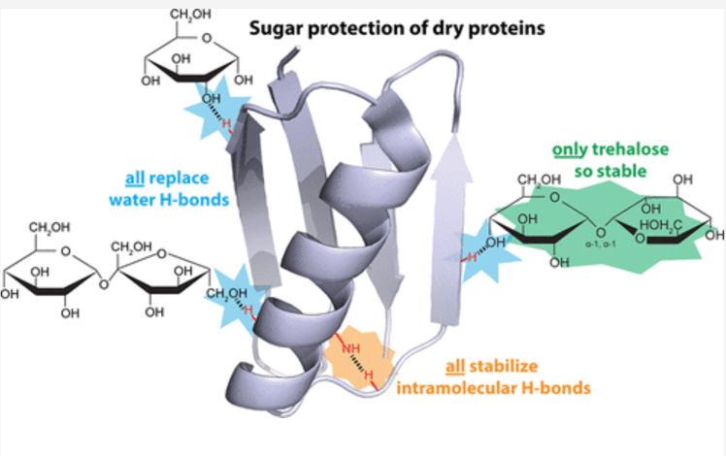
In this research project you will investigate immobilisation strategies which can be used to stabilise enzymes. Catalase will be used as a model enzyme as it facilitates the decomposition of hydrogen peroxide and can be easily extracted from potatoes. The activity of catalase will be measured by monitoring the formation of oxygen from hydrogen peroxide as seen in the chemical equation given below:
2H₂O_{2(aq)} → 2H₂O_{(l)} + O_{2(g)}

As enzymes are highly complex protein molecules, stabilisation strategies need to strengthen the bonds within the secondary and tertiary structure. One promising immobilisation strategy is where small sugars, such as glucose and fructose, are used to maintain the shape of the active site by forming hydrogen bonds with the enzyme [2].

Reference
- Nguyen HH, Lee SH, Lee UJ, Fermin CD, Kim M. Immobilized Enzymes in Biosensor Applications. Materials (Basel). 2019 Jan 2;12(1):121., www.ncbi.nlm.nih.gov, [date accessed 19 Feb 2024]
- Brom JA , Petrikis RG and Peilak GJ (2023) How sugars protect dry protein structure, Biochemistry, www.pubs.acs.org, 1044–1052 [date accessed 20 Feb 2024]

Catalase base method

Materials
- catalase solution prepared from potato
- 5 mL bulb pipette
- 5 mL graduated pipette
- deionised water
- test tubes x 3 per group
- permanent marker
- 15 cm metric ruler
- Hot (50ºC) water bath
- ice water bath (250 mL beaker with ice)
- masking tape to label test tubes
- hydrogen peroxide in small bottle (8% v/v)
- stop watch

Procedure
- Use a 5 mL bulb pipette to transfer 5 mL catalase solution into each of 3 test tubes. Draw a line at the surface of the solution.
- Label your test tubes as cold, hot or the control (room temp). Place the labels on the top of the test tubes so they do not come off in the water baths.
- COLD: Make an ice bath by placing 3-4 ice cubes in a 250 mL beaker with just enough water to submerge the test tubes. Place the test tube labelled COLD into the water bath for 5 minutes.
- HOT: Place the test tube labelled HOT into the test tube rack in the hot water bath at 50ºC for 5 minutes.
- CONTROL: Leave the control on the bench at room temperature.
- After 5 minutes, use a 5 mL graduated pipette to add 1 mL of 8% v/v hydrogen peroxide to each test tube. Set the stop watch.
- Wait for the foam to rise up the centrifuge tubes. Draw a line at the top of the foam at the same time.
- Measure the height of the foam in the test tube and record your data in a results table.

Research Question
A research question is used to guide all parts of the investigation. The research question must not be too broad. For example, “What type of starch can be used to make the best bioplastic?” is too broad are there are many different types of starch and how is it possible to measure ‘best’?
A more specific research question could be; “What type of starch (potato, tapioca or cornflour) produces bioplastics with the greatest tensile strength?”

________________________________________________________________________________________________________________________________________________________________________

Research Question Checklist
Includes the variable(s) that will be changed.
states what will be affected

Variables
Identify the independent, dependent and controlled variables. Use the table below as a guide.
Independent Variable (IV)  What will you be changing? | Dependent variable (DV)  What change will you be measuring? Include units | Controlled variables  What will you keep constant?  You need at least 5 controlled variables

Aim
The aim states the purpose of the experiment where, you need to include specific details of your IV and DV. The sentence should also start with a verb, such as “to investigate, to measure, to verify or to determine”.
_____________________________________________________________________________________________________________________________________________________________________________

Aim Checklist
States what will be done and how it will be measured
Uses a verb to begin sentence

Hypothesis
A hypothesis is a prediction about the relationship that you expect to occur between your IV and DV. It must be written using the following sentence structure.
If independent variable increases/decreases then dependent variable increases/decreases because….insert theory to justify your hypothesis
______________________________________________________________________________________________________________________________________________________________________________________________
_______________________________________________________________________________________________
_______________________________________________________________________________________________

Hypothesis Checklist
Show the dependence between independent and dependent variables
Includes theory to justify your hypothesis

Introduction
Use the information from your background and variables research to complete your introduction plan below by:
- describing the problem and the importance of your investigation.
- explaining what scientists already know about the topic.
- identifying the current gaps in scientific knowledge or understanding that need to be addressed.
- stating your aim.
- stating your hypothesis with a justification for your prediction. Usually written using the 'If… then… because' sentence structure.

- Describe the problem (include at least one piece of data/statistic) (Maximum 150 words)
2 sentences
____________________________________________________________________________________________________________________________________________________________________________________________________________________________________________________________________________________________________________________________________________________________________________________________

- What is already known (include key scientific information/data)
2 -3 sentences
____________________________________________________________________________________________________________________________________________________________________________________________________________________________________________________________________________________________________________________________________________________________________________________________

- Gaps in knowledge (link what we don’t know to your experiment)
1-2 sentences
_____________________________________________________________________________________________________________________________________________________________________________________________________________________________________________________________________________________________

- Aim
1 sentence
_____________________________________________________________________________________________________________________________________________________________________________________________________________________________________________________________________________________________

- Hypothesis
1 sentence
____________________________________________________________________________________________________________________________________________________________________________________________________________________________________________________________________________________________________________________________________________________________________________________________

Methodology

Instructions
Write a list of the equipment and materials that you will use in the experiment.
- Indicate the quantity of each item that you will need.
- Write out the method for your investigation. This should be step by step and in past tense.

Materials Checklist
All equipment and chemicals are listed
Includes the amounts of each item
All materials can be obtained

Materials

Method

Procedure Checklist
Numerical steps are used
The steps are in correct order
Quantity of each item included
Is written in past tense

Risk Assessment
Whenever conducting an experiment, it is important to identify the hazards and then state what precautions will be taken to prevent injury. This section must be completed before the experiment is conducted.

Equipment/Chemical or Process | Hazard | Safety Precaution

Table of results
Set up your results table by
- writing a descriptive title.
- labelling your independent and dependent variables.
- including your units.
- Record your data directly into your results table as you are completing your experiment

You need to include a MINIMUM of 3 replicates.

Title: ___________________________________________________________________________

Dependent Variable (unit):
Independent Variable: | Replicate 1 | Replicate 2 | Replicate 3

Table Checklist
Includes a descriptive title
Includes 3 or more replicates
Heading given for each column
Units are included
The independent variable is in the left column

Experimental Log

Instructions
- During each experiment session, list the tasks that you were able to complete.
- Insert observations and notes regarding the changes you are observing, any unexpected results, difficulties or ways to improve the experiment. Include any raw data from the session.
- Remember to take photographs of your experimental work for your poster.
- Make any required alterations in your proposed tasks for the following experimental session.

Note: This section MUST be completed as it is required for authentication of your work and forms part of your assessment.

Experimental session one
Observations, notes and raw data collected

Experimental session two
Observations, notes and raw data collected

Graph

Instructions
- Use the confidence interval excel spreadsheet to create a graph.
- Include all the graph requirements and upload to SEQTA.
- Insert a screen shot of graph on your poster for assessment.

Graphs need to include a title that describes the data, labels on the axes with units and an appropriate scale. The independent variable should be on the x axis. The graph needs to be drawn electronically.

The 95% confidence interval is the range of values where you are 95% confident that the mean (or average) of the experimental replicates exists. These range of values can be plotted on a graph by using bars on the end of lines. An example of a bar graph with 95% confidence intervals is shown below. As the confidence intervals overlap this indicates that the treated samples are not statistically different from the controlled samples.
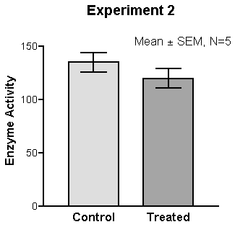

Graph Checklist
Is a suitable graph for the data
Includes a title
Axes are labelled
Units are included
Appropriate scale is used
The independent variable is on the x axis
95% CI included

Discussion and Conclusion Plan
Only use dot points as you will write the discussion and conclusion in class under test conditions.

Reporting Data

Summarise the data (1-2 sentences)
Compare the important results and include numbers, e.g. the highest and lowest averages. DO NOT LIST YOUR VALUES. Describe any trends or patterns you may observe. Do not discuss key findings.
____________________________________________________________________________________________________________________________________________________________________________________________________________________________________________________________________________________________________________________________________________________________________________________________

Evaluates the quality of the data - accuracy and precision (2-3 sentences)
Use selected measurement terms, such as precision and accuracy to evaluate the quality of the data. Elaborate on the measurement terms and use the 95% confidence intervals to help clarify the precision and significance of your collected data.
____________________________________________________________________________________________________________________________________________________________________________________________________________________________________________________________________________________________________________________________________________________________________________________________

Key finding - related to aim (1 sentence)
Simply state what you found out by looking at your data or your observations.
____________________________________________________________________________________________________________________________________________________________________________________________________________________________________________________________________________________________________________________________________________________________________________________________

Theory to explain key finding with in-text citations (3-4 sentences)
Use science theories to explain your key finding. Insert an intext citation to reference where you obtained the scientific information. Include the reference in your bibliography.
________________________________________________________________________________________________________________________________________________________________________________________________________________________________________________________________________________________________________________________________________________________________________________________________________________________________________________________________________________________________________________________________________________________________________________________________________________________________________________________________________________________________________________________________________________________________________________________

Links key findings to hypothesis and other science studies (2 sentences)
Remember to include intext citations.
___________________________________________________________________________________________________________________________________________________________________________________________________________________________________________________________________________________________________________________________________________________________________________________________________________________________________________________________________________________________

Errors in method

Random error (2 sentences)
Identify an error in the measurement which causes the values to vary.
____________________________________________________________________________________________________________________________________________________________________________________________________________________________________________________________________________________________________________________________________________________________________________________________

Effect on quality of data (1 -2 sentences)
Explain how the error affected your collected data. Did the error result in the values being more variable (data points are further apart)? Random errors affect the reliability of the experiment.
____________________________________________________________________________________________________________________________________________________________________________________________________________________________________________________________________________________________________________________________________________________________________________________________

Modification to address random error (1-2 sentences)
Identify a modification that could be made to the method/equipment to overcome the random error.
____________________________________________________________________________________________________________________________________________________________________________________________________________________________________________________________________________________________________________________________________________________________________________________________

Effect of modification on quality of data (1 sentence)
Explain how the modification would affect the reliability of your data.

____________________________________________________________________________________________________________________________________________________________________________________________________________________________________________________________________________________________________________________________________________________________________________________________

Systematic error (2 sentences)
Identify an error which created bias in the data. That is, the practical value differed from the true value by the same amount each time.
____________________________________________________________________________________________________________________________________________________________________________________________________________________________________________________________________________________________________________________________________________________________________________________________

Effect of error on quality of data (1-2 sentences)
Explain how the error affected your data. Would the error make the data higher (overestimation) or lower (underestimation) than the theoretical value? Systematic errors affect the validity of the experiment.
____________________________________________________________________________________________________________________________________________________________________________________________________________________________________________________________________________________________________________________________________________________________________________________________

Modification to address systematic error (1-2 sentences)
Identify a modification that could be made to the method/equipment to overcome the systematic error and ensure the practical value is closer to the theoretical value.
____________________________________________________________________________________________________________________________________________________________________________________________________________________________________________________________________________________________________________________________________________________________________________________________

Effect on modification quality of data (1 sentence)
Explain how the modification would the quality of your collected data.
____________________________________________________________________________________________________________________________________________________________________________________________________________________________________________________________________________________________________________________________________________________________________________________________

Conclusion (4 sentences)

Summarise key finding
Clearly state the overall finding as a bold confident sentence.
_____________________________________________________________________________________________________________________________________________________________________________________________________________________________________________________________________________________________

Describes extent to which analysis answered research question
In what contexts might the overall findings not apply or be true? However…..
____________________________________________________________________________________________________________________________________________________________________________________________________________________________________________________________________________________________________________________________________________________________________________________________

Recommendations
What should other scientists study/investigate next? Therefore….
____________________________________________________________________________________________________________________________________________________________________________________________________________________________________________________________________________________________________________________________________________________________________________________________

Implications
What does the overall finding mean for the scientific community or wider general population. Link this to the context of the aim and your generalisation.
____________________________________________________________________________________________________________________________________________________________________________________________________________________________________________________________________________________________________________________________________________________________________________________________

Bibliography
Use the numbered referencing style where references are indicated in-text by superscript numbers, or numbers in brackets. Each number corresponds to a particular source and refers to the bibliography list and provides full details of the sources used, arranged in the order they first appear in the text. Save your references for later inclusion in your poster.
Number– author (date) title of article, book title, web address, date accessed.
eg. 1. Williams (2016) Multiple Myeloma, Encyclopaedia Britannica, www.school.eb.com.au, [date accessed 11th February 2017]
________________________________________________________________________________________________________________________________________________________________________________________________________________________________________________________________________________________________________________________________________________________________________________________________________________________________________________________________________________________________________________________________________________________________________________________________________________________________________________________________________________________________________________________________________________________________________________________
____________________________________________________________________________________________________________________________________________________________________________________________________________________________________________________________________________________________________________________________________________________________________________________________

