11 Chemistry SAC 4 Problem solving task: revision lesson 1 ANSWERS

Revision Task: Investigating the Chemistry Behind Household Products

Introduction
You have been selected to work as a junior chemist for a consumer science company. Your team has been asked to investigate and report on the chemical composition, structure, and properties of substances found in common household items such as cleaners, plastics, and personal care products.
Over six research stations, you will complete quantitative and qualitative analysis. Your findings will be used by the company to identify the key compounds in products from a range of companies.

Task Instructions
- Work collaboratively at each station.
- Record your working, explanations, and diagrams clearly.

Station 1: Isotopes and Mass Spectra - Answers
Relevant key knowledge descriptors
- the relative isotopic masses of isotopes of elements and their values on the scale in which the relative isotopic mass of the carbon-12 isotope is assigned a value of 12 exactly
- determination of the relative atomic mass of an element using mass spectrometry (details of instrument not required)

Answers

Step 1: Interpret the Mass Spectrum
Examine the peaks on the mass spectrum.
- Identify:
- The mass-to-charge ratios (m/z) for each isotope.
- The relative abundance (%) of each isotope.

Step 2: Record the Isotope Data
Make a table showing:
Isotope (m/z) | Relative Abundance (%)
³⁵Cl | 75.80
³⁷Cl | 24.20

Step 3: Calculate the Relative Atomic Mass
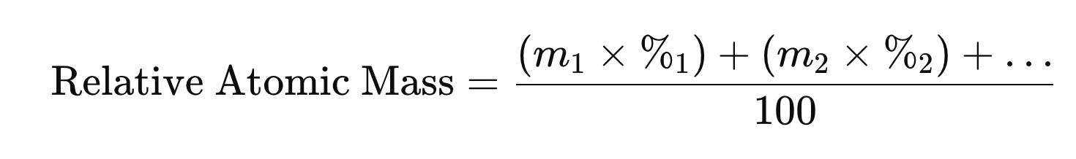

RAM = 35 x 75.80 + 37 x 24.20
100

RAM = 35.48

This value matches the relative atomic mass of chlorine of 35.5

This is the same value as that given on the periodic table, so the element is naturally occurring.

Station 2: Moles, Particles & Formulas - Answers

Step 1: Calculate the Number of Particles
Given: Mass of sample = 1.5 g
Required: Number of particles (atoms or molecules)
- Calculate moles using molar mass
Use the formula: n = m/M; n =m/M
n = 1.5/180 = 0.00833 mols
- Calculate number of particles
Use Avogadro’s constant: 6.02 x 10²³ Number of particles = 0.00833 x 6.02 x 10²³
= 5.01 x 10²¹ particles

Step 2: Calculate the Empirical Formula
Given: Percentage composition (e.g., 40% C, 6.7% H, 53.3% O)
Given:
C = 40.0 g
H = 6.7 g
O = 53.3 g
Step 1: Convert to moles
C: 40.0/12.01 = 3.33 mol
H: 6.7/1.008 = 6.65 mol
O: 53.3/16.00 = 3.33 mol
Step 2: Divide by smallest
C: 3.333.33 = 1
H: 6.653.33 ≈ 2
O: 3.333.33 =1

Empirical formula:
CH₂O

Step 4: Determine the Molecular Formula
Given: Molar mass of the actual compound;
Step 1: Empirical formula mass
- CH₂O = 12.01 + (2 × 1.008) + 16.00 = 30.03 g/mol
Step 2: Calculate ratio (n):
n = 180/30.03 ≈ 6
Step 3: Multiply subscripts in CH₂O by 6
- C₆H₁₂O₆
The compound in the water purifying tablet is sucrose, otherwise known as sugar.

Station 3: Representing Organic Compounds - Answers
Scenario: You've been asked to identify an unknown organic molecule found in a cleaning product. It is known that the compound does not have an carbon-carbon double bonds and one of the carbon atoms in the molecule has bond angles of 120°.

Your Tasks:
- Use the molecular modelling kits to build molecular models of the compounds; ethane, ethene, ethanol, ethanoic acid.
- Draw both the structural and semi-structural formulas of the molecules.
- Remove the bonds and atoms and replace in the kits when you have completed the task.

Relevant key knowledge descriptor
- representations of organic compounds (structural formulas, semi-structural formulas) and naming according to the International Union of Pure and Applied Chemistry (IUPAC) systematic nomenclature (limited to non-cyclic compounds up to C8, and structural isomers up to C5)

ethane ethene ethanol ethanoic acid.
CH₃CH₃ CH₂CH₂ CH₃CH₂OH CH₃COOH

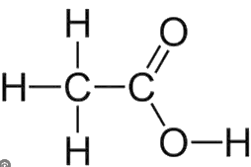
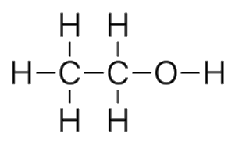
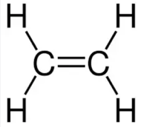
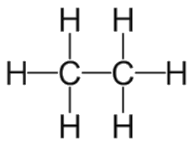

The bond angles between the carbonyl (C=O) and hydroxyl bonds (OH) is 120º. This indicates that the organic molecule is ethanoic acid, which at dilute concentration is known as vinegar.

Station 4: Naming Organic Compounds - Answers
Scenario: The company has given you the task of determining an unknown organic compound which can be used as a disinfectant. It is known that the compound has a molar mass less than 65 g.mol⁻¹ belongs to the alcohol family.

Your Tasks:
- Name structures A to F given below.
- Identify which molecules belong to the alcohol family.
- Determine which alcohol molecule has a molar mass less than 65 g.mol⁻¹

Relevant key knowledge descriptor
- representations of organic compounds (structural formulas, semi-structural formulas) and naming according to the International Union of Pure and Applied Chemistry (IUPAC) systematic nomenclature (limited to non-cyclic compounds up to C8, and structural isomers up to C5)

The disinfectant is 2 propanol. It has a molar mass is 60.1 g.mol⁻¹ and is less than 65 g.mol⁻¹.
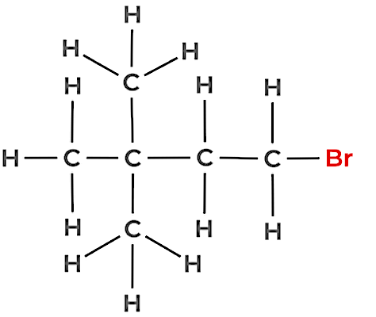
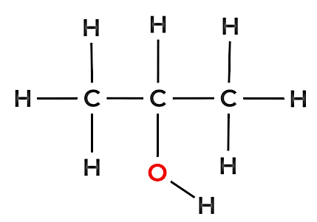
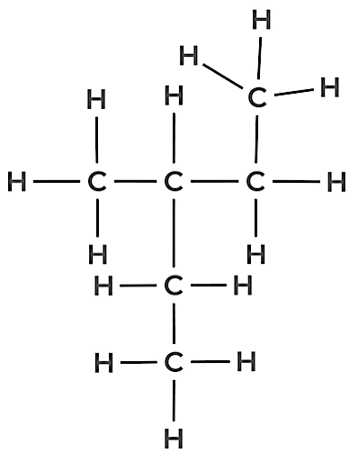
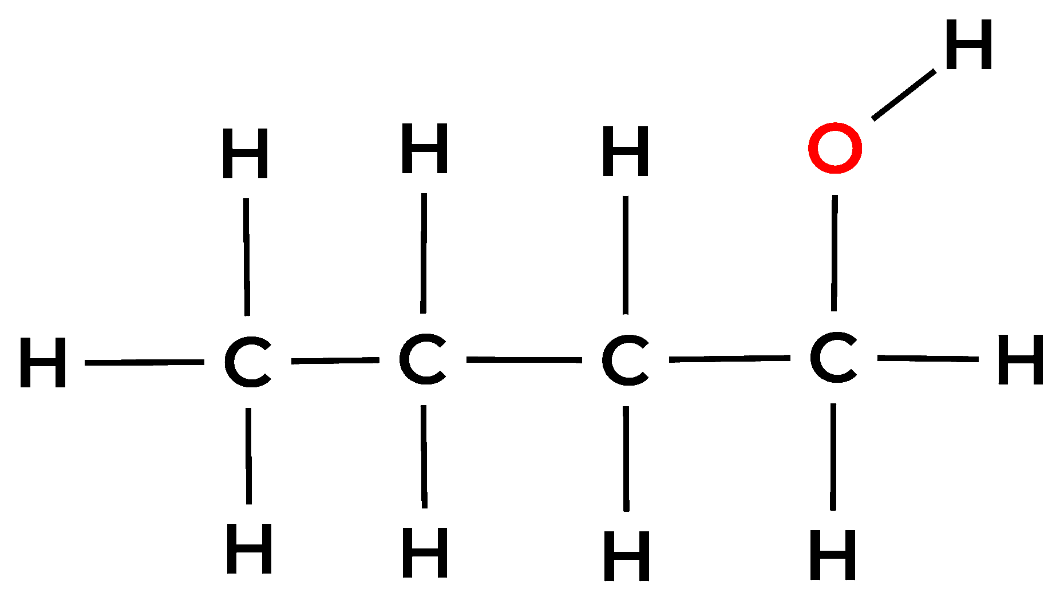
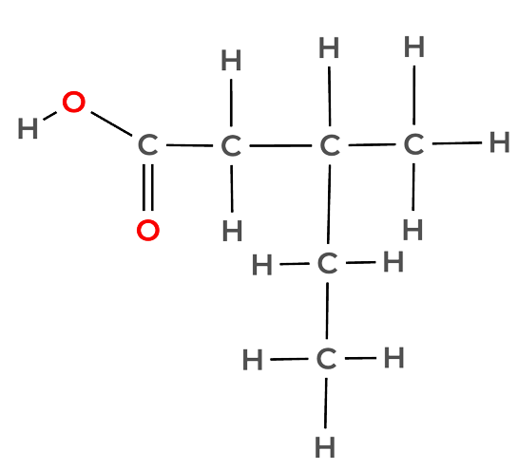
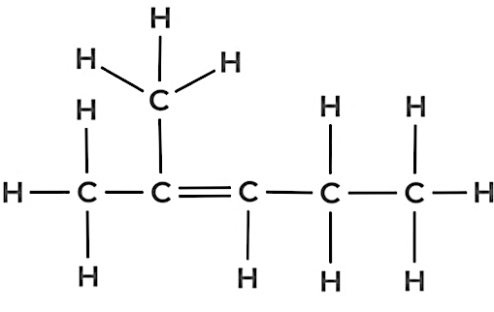
Structure A 2 methyl 2-pentene
Structure B 3 methyl pentane
Structure C 1 bromo 3,3 dimethyl butane
Structure D 2-propanol Molar mass 60.1 g.mol⁻¹
Structure F 3 methyl pentanoic acid
Structure E 1 butanol Molar mass 74.1 g.mol⁻¹

Station 5: Properties of Organic Families - Answers
Scenario: You have been asked to advise a cleaning company on which organic compounds are best for cleaning and product performance.

Your Tasks:
- Classify the list of compounds into their correct organic families.
- Predict physical and chemical properties.
- Suggest which of the compounds could be used as a cleaner based on those properties.

Relevant key knowledge descriptor
- the grouping of hydrocarbon compounds into families (alkanes, haloalkanes, alkenes, alcohols, carboxylic acids) based upon similarities in their physical and chemical properties, including general formulas and general uses based on their properties

Compound | Formula | Organic Family | Boiling point (ºC) | Solubility in water | Polarity | State at room temp | Odour
Methanol | CH₃OH | alcohol | 65 | soluble | polar | liquid | slightly sweet, alcohol-like
Ethanoic acid | CH₃COOH | carboxylic acid | 118 | soluble | polar | liquid | vinegar
Hexane | C₆H₁₄ | alkane | 69 | insoluble | non-polar | liquid | solvent smell
Propene | C₃H₆ | alkene | -47.6 | insoluble | non-polar | gas | faintly sweet
Ethanol | C₂H₅OH | Alcohol | 78 | soluble | polar | liquid | alcohol odour
Butanoic acid |  | carboxylic acid | 164 | somewhat soluble | polar | liquid | rancid (like vomit)
  C₃H₇COOH

Compound | Formula | Why it’s used
methanol | CH₃OH | Small alcohol; used as a solvent and disinfectant, but toxic – used industrially.
ethanoic acid | CH₃COOH | Also known as acetic acid; effective in removing mineral deposits, mould, and odours.
ethanol | C₂H₅OH | Widely used as a disinfectant, solvent, and sanitiser; kills microbes.

Station 6: Designing with Polymers - Answers
Scenario: You have been asked by a global outdoor and sports company to design a reusable plastic container that is heat-resistant. The company has also requested that you provide the chemical equations for the addition reactions for the monomers, ethene and propene.

Designing a Heat-Resistant Reusable Plastic Container

1. Comparison of Polymer Types
- Linear (Thermoplastic) Polymers
  - Made of long chains with minimal cross-linking (only dispersion forces) so less heat resistance.
  - Soften when heated and can be reshaped—making them recyclable. Examples: Polyethylene (PE), Polypropylene (PP).
- Cross-Linked (Thermosetting) Polymers
  - Have chemical bonds linking chains together in a 3D network. Examples: Bakelite, Melamine.
  - Do not melt when heated and are highly heat-resistant so are not recyclable.

2. Recommendations
- For a heat-resistant reusable container, a cross-linked (thermosetting) polymer is the better choice because it maintains shape and strength at high temperatures and is durable and resistant to thermal deformation.
- However, as it also needs to be recyclable, a thermoplastic like polycarbonate or high-density polyethylene which have stronger intermolecular bonding could be a compromise.

3. Monomer Choice and effect of chain length and branching on the properties
- A suitable monomer for a moderately heat-resistant polymer could be ethene (for polyethylene) or propene (for polypropylene).
- To improve performance:
  - Chain Length: increased strength and melting point due to more dispersion forces.
  - Branching:
    - Less branching → tighter packing, stronger forces → more rigid and heat-resistant.
    - More branching → flexible but lower melting point.
4. Chemical equations for the ethene and propene addition reactions.
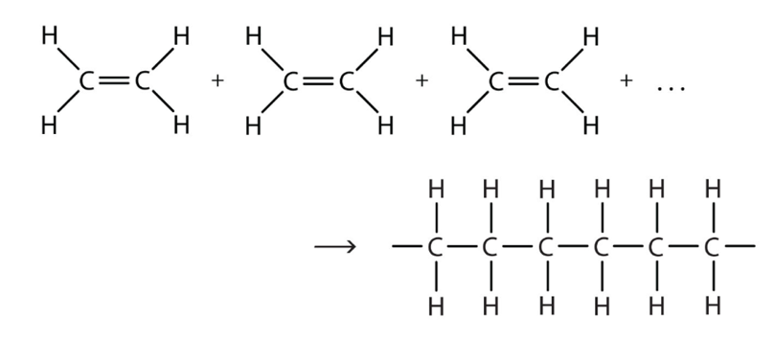
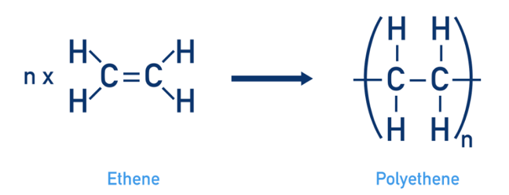 or

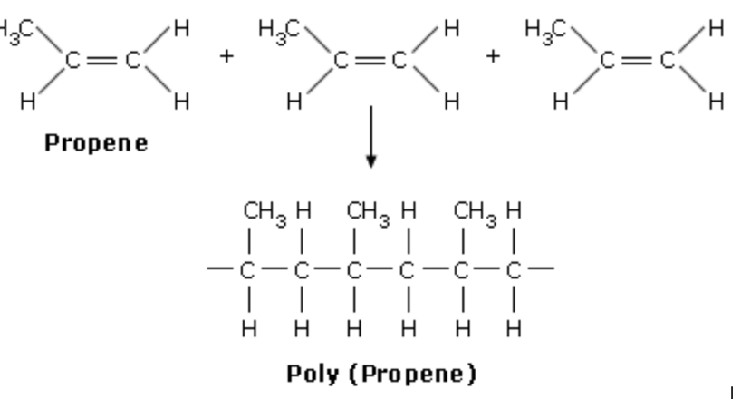
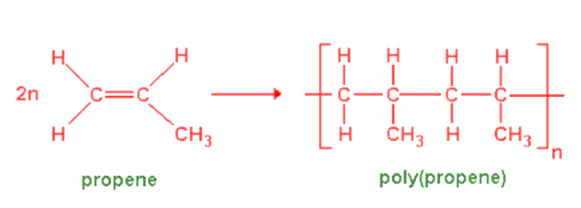or

