11 Chemistry SAC 4 Problem solving task: revision lesson 1 Name: ____________________

Revision Task: Investigating the Chemistry Behind Household Products

Introduction
You have been selected to work as a junior chemist for a consumer science company. Your team has been asked to investigate and report on the chemical composition, structure, and properties of substances found in common household items such as cleaners, plastics, and personal care products.
Over six research stations, you will complete quantitative and qualitative analysis. Your findings will be used by the company to identify the key compounds in products from a range of companies.

Task Instructions
- Work collaboratively at each station.
- Record your working, explanations, and diagrams clearly.

Station 1: Isotopes and Mass Spectra
Scenario: You’ve received a sample of a mystery element from a cleaning agent. You must analyse its isotopic data to determine its relative atomic mass and the element's identity. From this data you then need to identify whether the isotopic composition suggests it is naturally occurring or artificially enriched.

Your Tasks:
- Interpret the mass spectrum provided at the bench.
- Calculate the relative atomic mass of the element.
- Use your result to identify the element.
Relevant key knowledge descriptors
- the relative isotopic masses of isotopes of elements and their values on the scale in which the relative isotopic mass of the carbon-12 isotope is assigned a value of 12 exactly
- determination of the relative atomic mass of an element using mass spectrometry (details of instrument not required)

Station 2: Moles, Particles & Formulas
Scenario: A water purifying company has contacted you as they have had complaints from customers that the supplied water-purifying tablet is making the water taste sweet. You have been given the task to identify an unknown compound in the water-purifying tablet. The laboratory has supplied you with the percentage composition of the compound and the molar mass.

Your Tasks:
- Calculate the number of particles in a 1.5 g sample using Avogadro’s constant.
- Use the percentage composition provided on the bench to calculate the empirical formula.
- Determine the molecular formula from the molar mass (provided on the bench).

Relevant key knowledge descriptors
- Avogadro’s constant as the number 6.02 × 10²³ indicating the number of atoms or molecules in a mole of any substance; determination of the amount, in moles, of atoms (or molecules) in a pure sample of known mass
- determination of the molar mass of compounds, the percentage composition by mass of covalent compounds, and the empirical and molecular formula of a compound from its percentage composition by mass

Station 3: Representing Organic Compounds
Scenario: You've been asked to identify an unknown organic molecule found in a cleaning product. It is known that the compound does not have an carbon-carbon double bonds and one of the carbon atoms in the molecule has bond angles of 120°.

Your Tasks:
- Use the molecular modelling kits to build molecular models of the compounds; ethane, ethene, ethanol, ethanoic acid.
- Draw both the structural and semi-structural formulas of the molecules.
- Remove the bonds and atoms and replace in the kits when you have completed the task.

Relevant key knowledge descriptor
- representations of organic compounds (structural formulas, semi-structural formulas) and naming according to the International Union of Pure and Applied Chemistry (IUPAC) systematic nomenclature (limited to non-cyclic compounds up to C8, and structural isomers up to C5)

Station 4: Naming Organic Compounds
Scenario: The company has given you the task of identifying an unknown organic compound which can be used as a disinfectant. The company has passed on the information that the compound has a molar mass less than 65 g.mol⁻¹ belongs to the alcohol family.

Your Tasks:
- Name structures A to F which have been provided on the bench.
- Identify which molecules belong to the alcohol family.
- Determine which alcohol molecule has a molar mass less than 65 g.mol⁻¹

Relevant key knowledge descriptor
- representations of organic compounds (structural formulas, semi-structural formulas) and naming according to the International Union of Pure and Applied Chemistry (IUPAC) systematic nomenclature (limited to non-cyclic compounds up to C8, and structural isomers up to C5)

Station 5: Properties of Organic Families
Scenario: You have been asked to advise a cleaning company on which organic compounds are best for cleaning and product performance.

Your Tasks:
- Classify the list of compounds by their organic families.
- Predict physical and chemical properties, of boiling point, solubility in water, polarity, state at room temperature, odour. The first substance has been completed for you.
- Suggest uses based on those properties and any additional research.

Relevant key knowledge descriptor
- the grouping of hydrocarbon compounds into families (alkanes, haloalkanes, alkenes, alcohols, carboxylic acids) based upon similarities in their physical and chemical properties, including general formulas and general uses based on their properties

Compound | Formula | Organic Family | Boiling point | Solubility in water | Polarity | State at room temp | Odour
Methanol | CH₃OH | alcohol | 65 | soluble | polar | liquid | slightly sweet, alcohol-like
Ethanoic acid | CH₃COOH
Hexane | C₆H₁₄
Propene | C₃H₆
Ethanol | C₂H₅OH
Butanoic acid
  C₃H₇COOH

Station 6: Designing with Polymers
Scenario: You have been asked by a global outdoor and sports company to design a reusable plastic container that is heat-resistant. The company has also requested that you provide the chemical equations for the addition reactions for the monomers, ethene and propene.

Your Tasks:
- Compare linear (thermoplastic) and cross-linked (thermosetting) polymers.
- Recommend which polymer type is best for heat resistance and recyclability.
- Suggest a suitable monomer and describe how chain length and branching affect performance.
- Give the addition reactions for the monomers, ethene and propene.

Relevant key knowledge descriptors
- the formation of addition polymers by the polymerisation of alkene monomers
- the distinction between linear (thermoplastic) and cross-linked (thermosetting) addition polymers with reference to structure and properties
- the features of linear addition polymers designed for a particular purpose, including the selection of a suitable monomer (structure and properties), chain length and degree of branching

Station 1: Isotopes and Mass Spectra - Bench
Relevant key knowledge descriptors
Scenario: You’ve received a sample of a mystery element from a cleaning agent. You must analyse its isotopic data to determine its relative atomic mass and the element's identity. From this data you then need to identify whether the isotopic composition suggests it is naturally occurring or artificially enriched.

Your Tasks:
- Interpret the mass spectrum provided.
- Calculate the relative atomic mass of the element.
- Use your result to identify the element.
- the relative isotopic masses of isotopes of elements and their values on the scale in which the relative isotopic mass of the carbon-12 isotope is assigned a value of 12 exactly
- determination of the relative atomic mass of an element using mass spectrometry (details of instrument not required)

Mass spectrum of unknown element
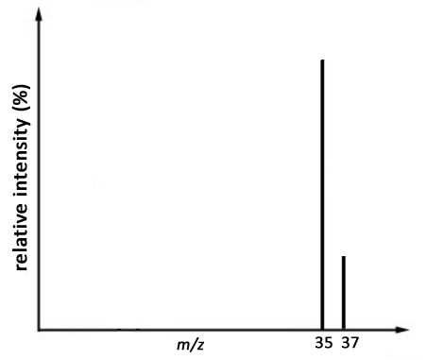
75.80%
24.20%

Station 2: Moles, Particles & Formulas - Bench
Scenario: A water purifying company has contacted you as they have had complaints from customers that the supplied water-purifying tablet is making the water taste sweet. You have been given the task to identify an unknown compound in the water-purifying tablet. The laboratory has supplied you with the percentage composition of the compound and the molar mass.

Your Tasks:
- Calculate the number of particles in a 1.5 g sample using Avogadro’s constant.
- Use the percentage composition to calculate the empirical formula.
- Determine the molecular formula from the molar mass.

Relevant key knowledge descriptors
- Avogadro’s constant as the number 6.02 × 10²³ indicating the number of atoms or molecules in a mole of any substance; determination of the amount, in moles, of atoms (or molecules) in a pure sample of known mass
- determination of the molar mass of compounds, the percentage composition by mass of covalent compounds, and the empirical and molecular formula of a compound from its percentage composition by mass

You're testing a 1.5 g powder from a water-purifying tablet.
The powder contains:
40.0% carbon (C)
6.7% hydrogen (H)
53.3% oxygen (O)
The molar mass of the compound is 180 g.mol⁻¹.

Station 3: Representing Organic Compounds - Bench
Scenario: You've been asked to identify an unknown organic molecule found in a cleaning product. It is known that the compound does not have carbon-carbon double bonds and one of the carbon atoms in the molecule has bond angles of 120°.

Your Tasks:
- Use the molecular modelling kits to build molecular models of the compounds; ethane, ethene, ethanol, ethanoic acid.
- Draw both the structural and semi-structural formulas of the molecules.
- Remove the bonds and atoms and replace in the kits when you have completed the task.

Relevant key knowledge descriptor
- representations of organic compounds (structural formulas, semi-structural formulas) and naming according to the International Union of Pure and Applied Chemistry (IUPAC) systematic nomenclature (limited to non-cyclic compounds up to C8, and structural isomers up to C5)

ethane ethene ethanol ethanoic acid

Station 4: Naming Organic Compounds - Bench
Scenario: The company has given you the task of identifying an unknown organic compound which can be used as a disinfectant. The company has passed on the information that the compound has a molar mass less than 65 g.mol⁻¹ belongs to the alcohol family.

Your Tasks:
- Name structures A to F given below.
- Identify which molecules belong to the alcohol family.
- Determine which alcohol molecule has a molar mass less than 65 g.mol⁻¹

Relevant key knowledge descriptor
- representations of organic compounds (structural formulas, semi-structural formulas) and naming according to the International Union of Pure and Applied Chemistry (IUPAC) systematic nomenclature (limited to non-cyclic compounds up to C8, and structural isomers up to C5)

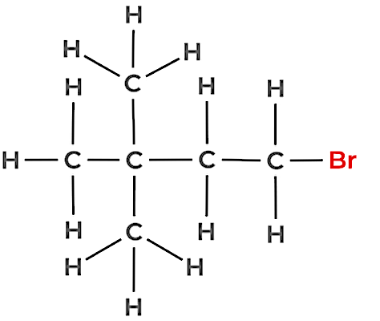
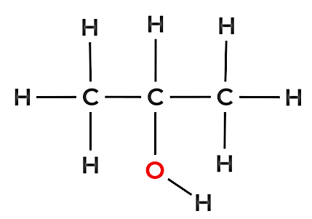
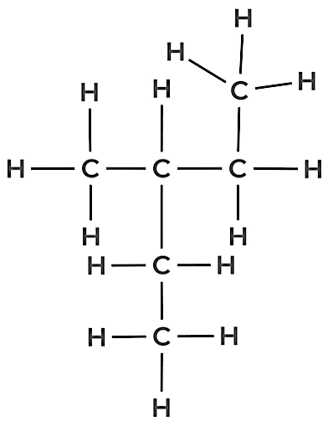
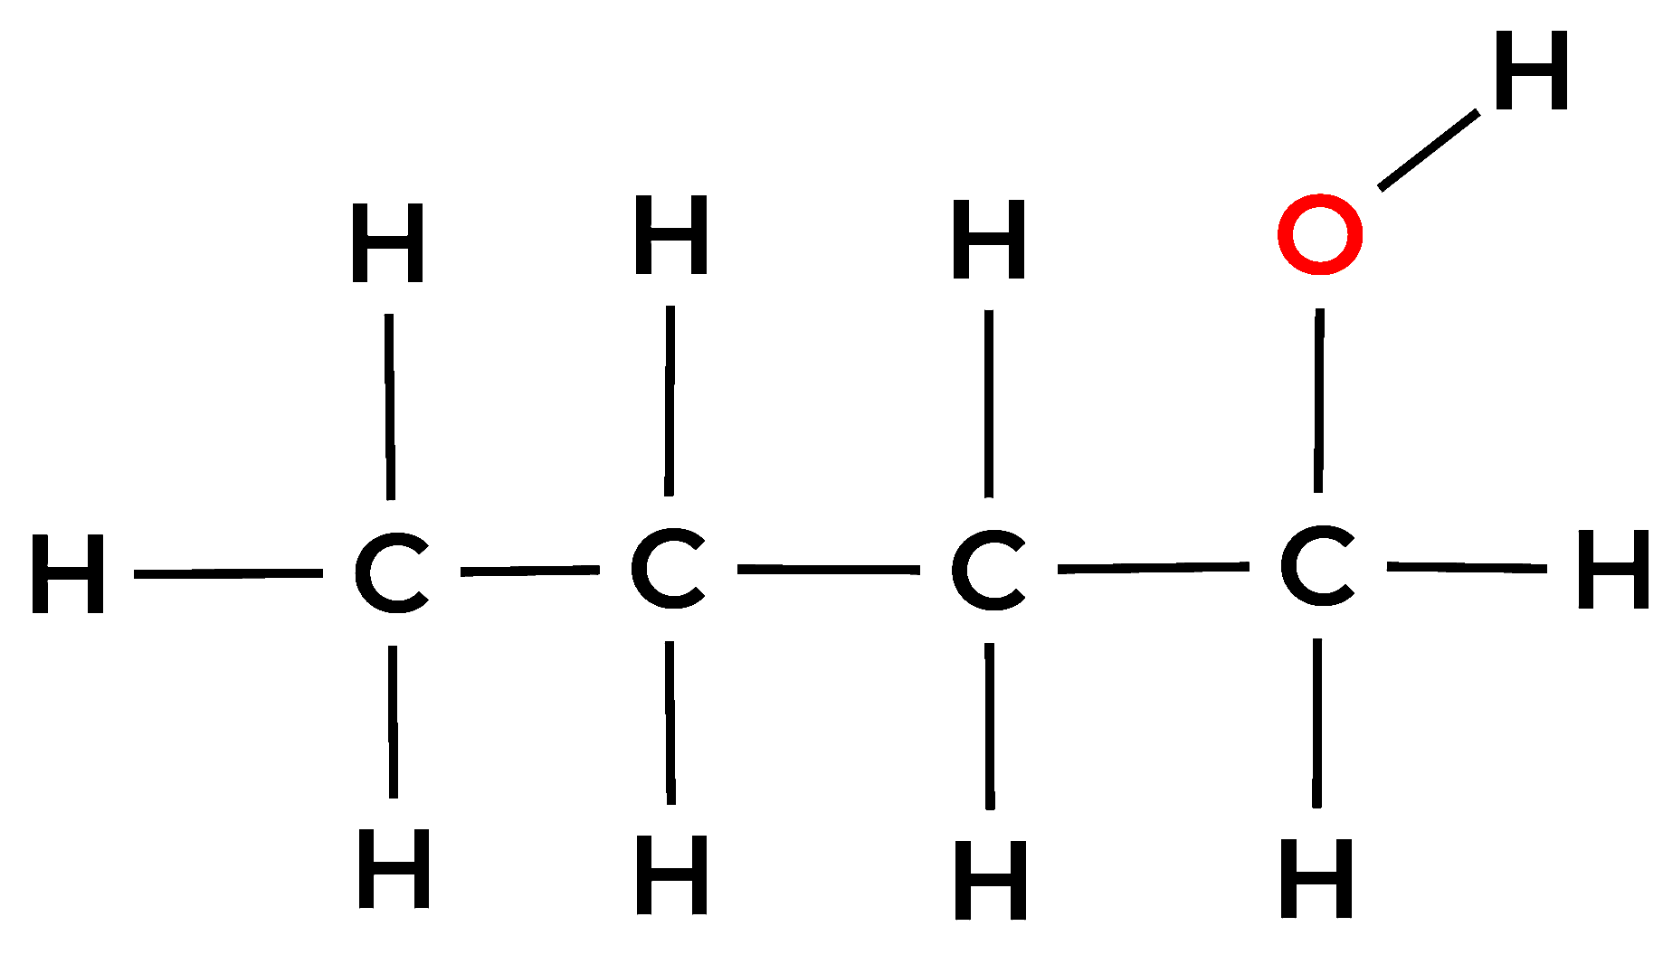
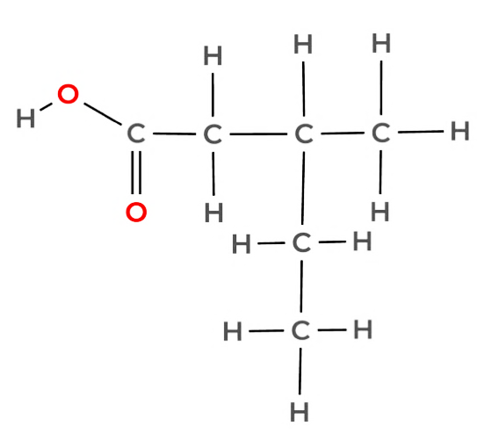
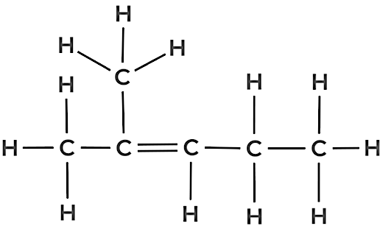
Structure A
Structure B
Structure C
Structure D
Structure F
Structure E

Station 5: Properties of Organic Families - Bench
Scenario: You have been asked to advise a cleaning company on which organic compounds are best for cleaning and product performance.

Your Tasks:
- Classify the list of compounds into their correct organic families.
- Predict physical and chemical properties.
- Suggest uses based on those properties.

Relevant key knowledge descriptor
- the grouping of hydrocarbon compounds into families (alkanes, haloalkanes, alkenes, alcohols, carboxylic acids) based upon similarities in their physical and chemical properties, including general formulas and general uses based on their properties

Compound | Formula | Organic Family | Boiling point | Solubility in water | Polarity | State at room temp | Odour
Methanol | CH₃OH
Ethanoic acid | CH₃COOH
Hexane | C₆H₁₄
Propene | C₃H₆
Ethanol | C₂H₅OH
Butanoic acid
  C₃H₇COOH

Station 6: Designing with Polymers - Bench
Scenario: You have been asked by a global outdoor and sports company to design a reusable plastic container that is heat-resistant. The company has also requested that you provide the chemical equations for the addition reactions for the monomers, ethene and propene.

Your Tasks:
- Compare linear (thermoplastic) and cross-linked (thermosetting) polymers.
- Recommend which polymer type is best for heat resistance and recyclability.
- Suggest a suitable monomer and describe how chain length and branching affect performance.
- Give the addition reactions for the monomers, ethene and propene.

Relevant key knowledge descriptors
- the formation of addition polymers by the polymerisation of alkene monomers
- the distinction between linear (thermoplastic) and cross-linked (thermosetting) addition polymers with reference to structure and properties
- the features of linear addition polymers designed for a particular purpose, including the selection of a suitable monomer (structure and properties), chain length and degree of branching

Station 1: Isotopes and Mass Spectra - Hints
Relevant key knowledge descriptors
Scenario: You’ve received a sample of a mystery element from a cleaning agent. You must analyse its isotopic data to determine its relative atomic mass and the element's identity. From this data you then need to identify whether the isotopic composition suggests it is naturally occurring or artificially enriched.

Your Tasks:
- Interpret the mass spectrum provided.
- Calculate the relative atomic mass of the element.
- Use your result to identify the element.
- the relative isotopic masses of isotopes of elements and their values on the scale in which the relative isotopic mass of the carbon-12 isotope is assigned a value of 12 exactly
- determination of the relative atomic mass of an element using mass spectrometry (details of instrument not required)

Hint

Step 1: Interpret the Mass Spectrum
Examine the peaks on the mass spectrum.
- Identify:
- The mass-to-charge ratios (m/z) for each isotope.
- The relative abundance (%) of each isotope.

Step 2: Record the Isotope Data
Make a table showing:
Isotope (m/z) | Relative Abundance (%)
... | ...
... | ...

Step 3: Calculate the Relative Atomic Mass
Use the formula: 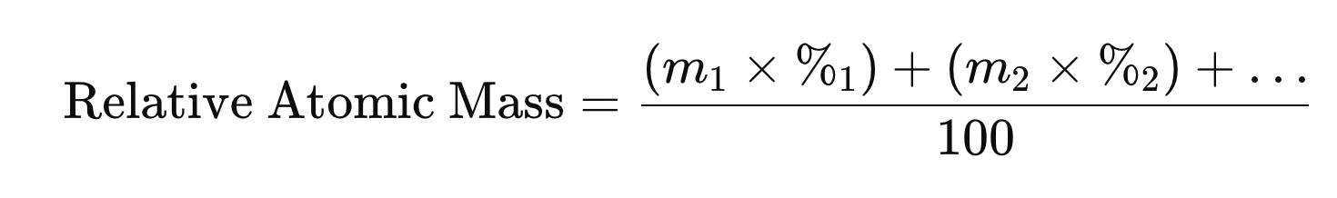

Station 2: Moles, Particles & Formulas - Hints
Scenario: A water purifying company has contacted you as they have had complaints from customers that the supplied water-purifying tablet is making the water taste sweet. You have been given the task to identify an unknown compound in the water-purifying tablet. The laboratory has supplied you with the percentage composition of the compound and the molar mass.

Your Tasks:
- Calculate the number of particles in a 1.5 g sample using Avogadro’s constant.
- Use the percentage composition to calculate the empirical formula.
- Determine the molecular formula from the molar mass.

Relevant key knowledge descriptors
- Avogadro’s constant as the number 6.02 × 10²³ indicating the number of atoms or molecules in a mole of any substance; determination of the amount, in moles, of atoms (or molecules) in a pure sample of known mass
- determination of the molar mass of compounds, the percentage composition by mass of covalent compounds, and the empirical and molecular formula of a compound from its percentage composition by mass

Hints

Step 1: Calculate the Number of Particles
Given: Mass of sample = 1.5 g
Required: Number of particles (atoms or molecules)
- Calculate moles using molar mass
Use the formula: n = m/M
- Calculate number of particles
Use Avogadro’s constant: 6.02 x 10²³ Number of particles = n x 6.02 x 10²³

Step 2: Calculate the Empirical Formula
Given: Percentage composition (e.g., 40% C, 6.7% H, 53.3% O)
- Convert percentages to grams (assume 100 g total sample).
  - Example: 40% C → 40 g C
- Convert grams to moles of each element. n = m/M
- Divide each mole value by the smallest mole value to get a whole number ratio.
- Write the empirical formula using the ratio of atoms.

Step 4: Determine the Molecular Formula
Given: Molar mass of the actual compound;
- Calculate empirical formula mass (sum of atomic masses in the empirical formula).
- Find the ratio:
- Multiply each subscript in the empirical formula by n to get the molecular formula.

