Multi-structural |  | Relational
  Bioethanol | Petrol   | Why is bioethanol considered a renewable fuel while petrol isn’t?  Why does bioethanol have a lower energy content than petrol?  Compare the advantages and disadvantages of bioethanol relative to petrol.
Biodiesel  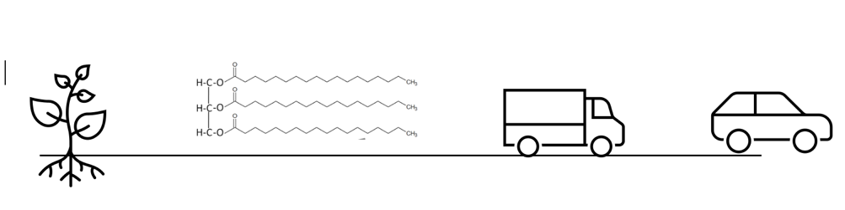 | Petrodiesel | Why is biodiesel considered to be more sustainable than petrodiesel?  - Distinguish the structural features of biodiesel compared with petrodiesel.  - Explain the effect of these structural differences on engine performance in cold climates.
Biogas  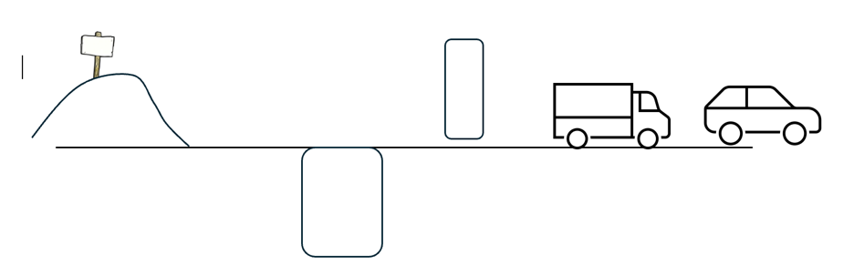 |   Natural Gas | Justify why biogas is considered more sustainable than natural gas and explain why biogas is not regarded as a carbon-zero fuel.  - Identify the main challenge associated with using biogas and natural gas as transport fuels.  - Explain how this challenge is addressed.

