12 Chemistry Ch 3.2 Limiting Reactants BCA Schema
Using the BCA Method (Before, Change, After)

Introduction: The Sandwich Analogy
Imagine you're making sandwiches for a party

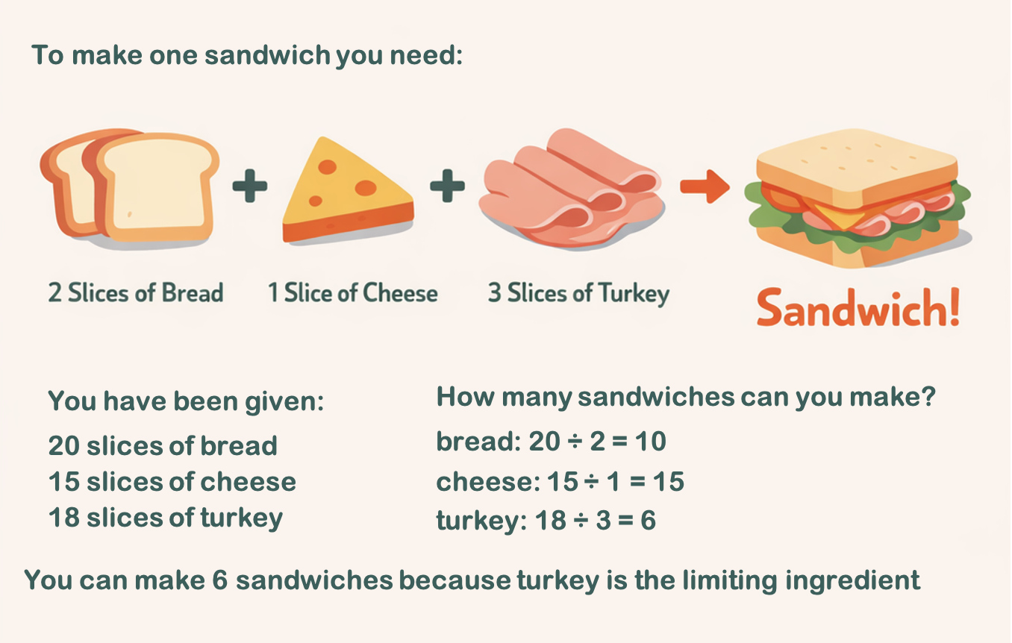

What is a Limiting Reactant?
In a chemical reaction, the limiting reactant is the reactant that is consumed first. This limits the amount of product that can be formed. The other reactants are in excess.
To find the limiting reactant, you can use the same method as in the sandwich where each ingredient is divided by the number required in the sandwich.
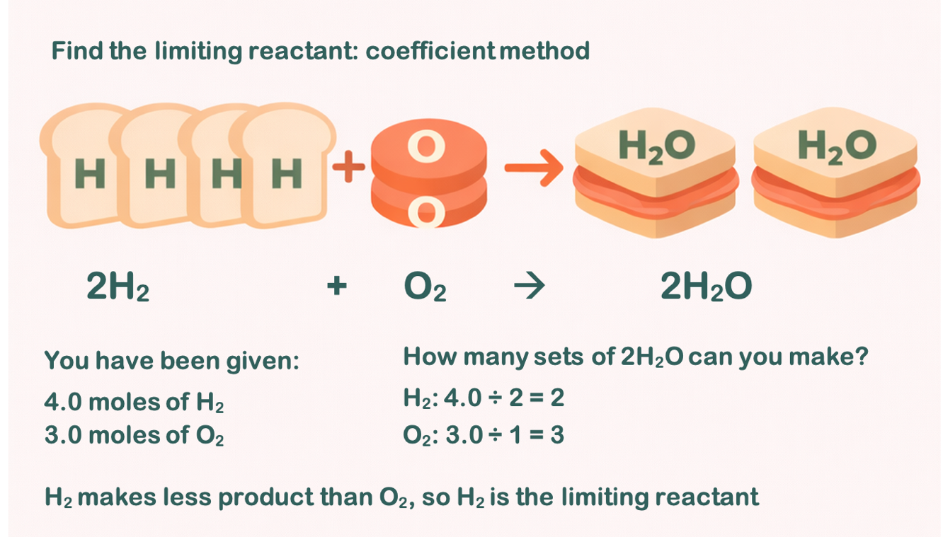

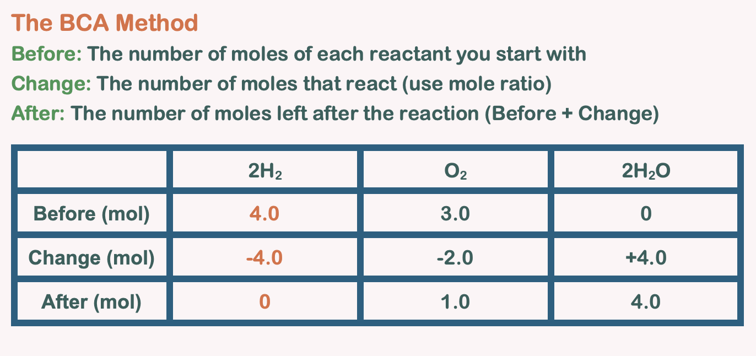

Worked Example 1: Formation of Water
Given: 4.0 moles of H₂ and 3.0 moles of O₂,
Calculate how many moles of each reactant and product remain once the reaction is complete.
Balanced equation: 2H₂ + O₂ → 2H₂O
Step 1: Determine the limiting reactant
Mole ratio method
From the equation, the mole ratio is n(H₂): n(O₂) 2:1
For 4.0 mol H₂, we need n(O₂) = ½ n(H₂), n(O₂) = 2.0 mol
As we have 3.0 mol O₂, this is MORE than 2.0 mol needed
Therefore, H₂ is the limiting reactant.
Coefficient method
Divide H₂ by the coefficient 2, and O₂ by the coefficient 1
H₂: 4.0 ÷ 2.0 = 2 O₂: 3.0 ÷ 1 = 3.0

H₂ can only provide enough for 2 batches of product (2 x 2H₂O), while O₂ could supply 3, making H₂ the limiting reactant.

Step 2: Set up the BCA table
 | 2H₂ | O₂ | 2H₂O
Before (mol) | 4.0 | 3.0 | 0
Change (mol) | -4.0 | -2.0 | +4.0
After (mol) | 0 | 1.0 | 4.0
Step 3: Explanation of the BCA table
Change row: Since H₂ is limiting, all 4.0 mol will react,

Find change using n(O₂): n(H₂) = 1: 2, n(H₂O): n(H₂) = 2:2, 1:1
- H₂ change: -4.0 mol (all consumed)
- O₂ change: ½ × - 4.0 = -2.0 mol
- H₂O change: 1 x 4.0 = +4.0 mol
After row: Before + Change for each substance
Answer: 4.0 moles of H₂O are produced, and 1.0 mole of O₂ remains unreacted.

Example 2: Combustion of Propane – Class task
Given: 2.5 moles of C₃H₈ and 15.0 moles of O₂
Calculate how many moles of each reactant and product remain once the reaction is complete.
Balanced equation: C₃H₈ + 5O₂ → 3CO₂ + 4H₂O
Step 1: Determine the limiting reactant
From the equation, the mole ratio is n(O₂): n(C₃H₈) = 5: 1
For 2.5 mol C₃H₈, we need n(O₂) = 5 x n(C₃H₈) = 12.5 mol
We have 15.0 mol O₂, which is MORE than 12.5 mol needed. Therefore, C₃H₈ is the limiting reactant.
Step 2: Set up the BCA table
 | C₃H₈ | 5O₂ | 3CO₂ | 4H₂O
Before (mol) | 2.5 | 15.0 | 0 | 0
Change (mol) | -2.5 | -12.5 | +7.5 | +10.0
After (mol) | 0 | 2.5 | 7.5 | 10.0
Step 3: Explanation of the BCA table
Change row: Since C₃H₈ is limiting (all 2.5 mol will react)
We use the mole ratios to find the change
- C₃H₈ change: -2.5 mol (all consumed)
- O₂ change: 2.5 × 5 = -12.5 mol
- CO₂ change: 2.5 × 3 = +7.5 mol
- H₂O change: 2.5 × 4 = +10.0 mol
After row: Before + Change for each substance
Answer: 7.5 moles of CO₂ and 10.0 moles of H₂O are produced, and 2.5 moles of O₂ remain unreacted.

12 Chemistry Ch 3.2 Limiting Reactants BCA Schema
Using the BCA Method (Before, Change, After)

Practice Problems
Problem 1: Given 6.0 moles of N₂ and 10.0 moles of H₂, how many moles of NH₃ can be produced?
N₂ + 3H₂ → 2NH₃
Step 1: Determine the limiting reactant

Before (mol)
Change (mol) | -2.5 | -12.5 | +7.5
After (mol) | 0 | 2.5 | 7.5

Problem 2: Given 5.0 moles of Fe and 4.0 moles of O₂, how many moles of Fe₂O₃ can be produced?
4Fe + 3O₂ → 2Fe₂O₃

Step 1: Determine the limiting reactant

Before (mol)
Change (mol) | -2.5 | -12.5 | +7.5
After (mol) | 0 | 2.5 | 7.5

Problem 3: Given 8.0 moles of Al and 9.0 moles of Cl₂, how many moles of AlCl₃ can be produced?
2Al + 3Cl₂ → 2AlCl₃
Step 1: Determine the limiting reactant

Before (mol)
Change (mol) | -2.5 | -12.5 | +7.5
After (mol) | 0 | 2.5 | 7.5

Problem 4: Given 10.0 moles of Mg and 4.0 moles of O₂, how many moles of MgO can be produced?
2Mg + O₂ → 2MgO
Step 1: Determine the limiting reactant

Before (mol)
Change (mol) | -2.5 | -12.5 | +7.5
After (mol) | 0 | 2.5 | 7.5

