12 Chemistry Ch 3.3 Bomb Calorimetry

A Three-Step Quokka Schema
Calculating Enthalpy of Combustion

What do quokkas have to do with bomb calorimetry?
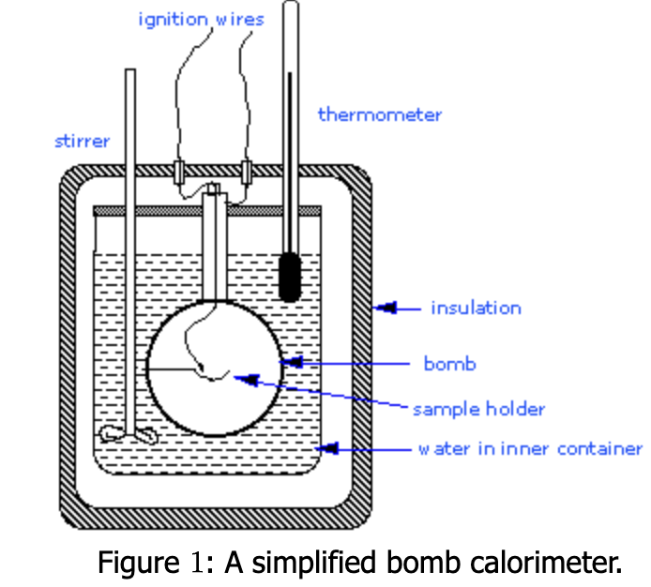
Bomb calorimetry is an experimental technique used to measure the heat released during combustion reactions which can then be used to calculate the heat of combustion (ΔH_{c}). By burning a substance such as a fuel or food in a sealed, container (the 'bomb') and measuring both the change in water temperature and the mass of the substance, we can determine how much energy is released during combustion.
Image: LibreTexts Chemistry

While the apparatus may seem complex, the calculation can be completed in a three-step process – which is where quokkas come in.

Quokkas, Naturally Happy
This statement can be used to remember the three steps in bomb calorimeter calculations.
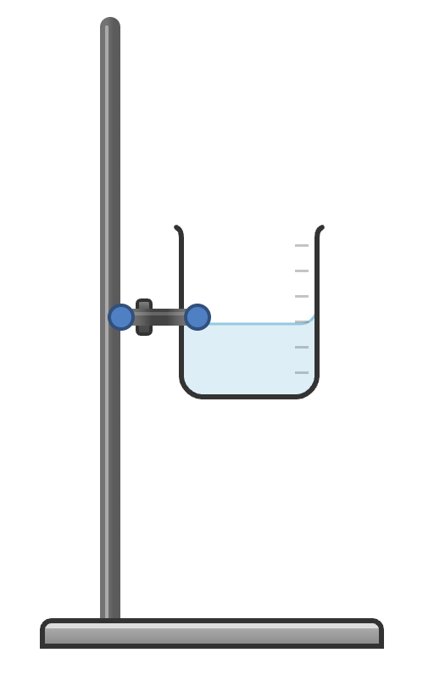

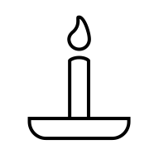
q = mcΔT
n = $\frac{m}{M}$
ΔH_{c} =- $\frac{q}{n}$
Quokka’s
Naturally
Happy

The Three-Step Framework
Every bomb calorimetry calculation follows the same logical sequence:
Quokka’s

Naturally

Happy

Step 1: Calculate the Energy Absorbed by Water (q)
First, determine how much heat energy was absorbed by the water surrounding the bomb calorimeter using the heat capacity equation:
q = mcΔT
q = mc(T_{f} − T_{i})
Where:
• q = heat energy absorbed by water (J or kJ)
• m = mass of water (g)
• c = specific heat capacity of water (4.18 J g⁻¹ °C⁻¹)
• T_{f} = final temperature (°C)
• T_{i} = initial temperature (°C)

Step 2: Calculate the Number of Moles (n)
Next, we determine how many moles of fuel were burned in the experiment:
n = $\frac{m}{M}$
Where:
• n = number of moles of fuel (mol)
• m = mass of fuel burned (g)
• M = molar mass of fuel (g mol⁻¹)

Step 3: Calculate the Enthalpy of Combustion (ΔH)
Now assuming that | q_{f} | =| q_{w}|, we combine the energy released with the number of moles to find the enthalpy of combustion per mole:
ΔH_{c} =- $\frac{q}{n}$
Where:
• ΔH_{c} = enthalpy of combustion (kJ mol⁻¹)
• q = heat absorbed by water (kJ)
• n = number of moles of fuel (mol)
• The negative sign indicates energy is released (exothermic)

Simplifying the Concept: Two Inputs, One Output
We can also think of the process as two inputs that combine to give us one output:
q = mcΔT
Total energy absorbed by the calorimeter
n = $\frac{m}{M}$
Number of moles of fuel combusted
ΔH_{c} =- $\frac{q}{n}$
Energy released per mole of fuel (enthalpy of combustion)

This simplified process shows that bomb calorimetry measures the total energy released by the substance, divided by the amount of the substance to get the energy per mole.

Worked Example

Example 1: Combustion of Ethanol
Problem:
A bomb calorimeter contains 1500 g of water. When 0.920 g of ethanol (C₂H₅OH, M = 46.0 g mol⁻¹) is burned, the temperature of the water rises from 20.0°C to 26.4°C. Calculate the enthalpy of combustion of ethanol.
Solution
Quokkas
Step 1: Calculate q (energy absorbed by water)
Given: m = 1500 g, c = 4.18 J g⁻¹ °C⁻¹, T_{i} = 20.0°C, T_{f} = 26.4°C
q = mc(T_{f} − T_{i})
q = 1500 x 4.18 x (26.4 − 20.0)
q = (1500)(4.18)(6.4) J
q = 40,128 q = 40.1 kJ
Naturally
Step 2: Calculate n (moles of ethanol)
Given: mass of ethanol = 0.920 g, M = 46.0 g mol⁻¹
n = m/M
n = 0.920 g / 46.0 g mol⁻¹
n = 0.0200 mol
Happy
Step 3: Calculate ΔH_{c}
ΔH_{comb} = −q/n
ΔH_{comb} = −40.1 kJ / 0.0200 mol
ΔH_{c} = −2005 kJ mol⁻¹
The negative sign indicates that combustion releases energy (exothermic reaction).

Example 2: Combustion of Glucose – Complete as a class
Problem:
A student burns 1.35 g of glucose (C₆H₁₂O₆, M = 180.0 g mol⁻¹) in a bomb calorimeter containing 2000 g of water. The temperature increases from 18.5°C to 22.8°C. Determine the enthalpy of combustion of glucose.
Solution:
Step 1: Calculate q
q = mc(T_{f} − T_{i})
q = (2000 g)(4.18 J g⁻¹ °C⁻¹)(22.8 − 18.5)°C
q = (2000)(4.18)(4.3) J
q = 35,948, q = 35.9 kJ
Step 2: Calculate n
n = m/M
n = 1.35 g / 180.0 g mol⁻¹
n = 0.00750 mol
Step 3: Calculate ΔH_{c}
ΔH_{comb} = −q/n
ΔH_{comb} = −35.9 kJ / 0.00750 mol
ΔH_{comb} = −4787 kJ mol⁻¹

12 Chemistry Ch 3.3 Bomb Calorimetry

A Three-Step Quokka Schema
Calculating Enthalpy of Combustion

Practice questions
Question 1:
A bomb calorimeter containing 1800 g of water shows a temperature increase from 19.2°C to 25.7°C when 0.750 g of methane (CH₄, M = 16.0 g mol⁻¹) is burned. Calculate the enthalpy of combustion of methane.

Question 2:
When 2.10 g of octane (C₈H₁₈, M = 114.0 g mol⁻¹) is combusted in a bomb calorimeter with 2500 g of water, the temperature rises from 20.0°C to 31.4°C. Determine the enthalpy of combustion of octane.

Question 3:
A calorimeter contains 1200 g of water at 21.5°C. After burning 0.580 g of propane (C₃H₈, M = 44.0 g mol⁻¹), the final temperature is 28.9°C. Calculate the enthalpy of combustion of propane.

Question 4:
A student measures the enthalpy of combustion of benzoic acid (C₇H₆O₂, M = 122.0 g mol⁻¹) using 1650 g of water. When 1.22 g of benzoic acid burns, the water temperature increases from 18.0°C to 26.8°C. What is the enthalpy of combustion?

Solutions to Practice Questions

Solution 1:
Step 1: q = mc(T_{f} − T_{i})
q = (1800)(4.18)(25.7 − 19.2) = (1800)(4.18)(6.5) = 48,906 J = 48.9 kJ
Step 2: n = m/M
n = 0.750 g / 16.0 g mol⁻¹ = 0.04688 mol
Step 3: ΔH_{comb} = −q/n = −48.9 kJ / 0.04688 mol
Answer: ΔH_{comb} = −1043 kJ mol⁻¹

Solution 2:
Step 1: q = (2500)(4.18)(31.4 − 20.0) = (2500)(4.18)(11.4) = 119,130 J = 119.1 kJ
Step 2: n = 2.10 g / 114.0 g mol⁻¹ = 0.01842 mol
Step 3: ΔH_{comb} = −119.1 kJ / 0.01842 mol
Answer: ΔH_{comb} = −6467 kJ mol⁻¹

Solution 3:
Step 1: q = (1200)(4.18)(28.9 − 21.5) = (1200)(4.18)(7.4) = 37,118 J = 37.1 kJ
Step 2: n = 0.580 g / 44.0 g mol⁻¹ = 0.01318 mol
Step 3: ΔH_{comb} = −37.1 kJ / 0.01318 mol
Answer: ΔH_{comb} = −2815 kJ mol⁻¹

Solution 4:
Step 1: q = (1650)(4.18)(26.8 − 18.0) = (1650)(4.18)(8.8) = 60,685 J = 60.7 kJ
Step 2: n = 1.22 g / 122.0 g mol⁻¹ = 0.01000 mol
Step 3: ΔH_{comb} = −60.7 kJ / 0.01000 mol
Answer: ΔH_{comb} = −6070 kJ mol⁻¹

Key Takeaways
1. Bomb calorimetry is systematic: Always follow the same three steps regardless of the fuel being tested.
2. Two inputs, one output: Energy absorbed (q) and moles of fuel (n) combine to give enthalpy of combustion.
3. Watch the sign: The negative sign in ΔH_{comb} = −q/n is not arbitrary—it reflects that combustion releases energy.
4. Units matter: Keep track of units throughout. Convert J to kJ where appropriate, and ensure your final answer is in kJ mol⁻¹.
5. Practice builds confidence: The more problems you work through, the more intuitive the process becomes.

Quokka’s
Naturally
Happy
q = mcΔT
n = $\frac{m}{M}$
ΔH = $\frac{q}{n}$

